Year 9 |  | Basic Geometry | Non Calculator
Skills and Knowledge Assessed:  - Use the language, notation and conventions of geometry  - Identify line and rotational symmetries (ACMMG181  - Recognise the geometrical properties of angles at a point.  - Identify corresponding, alternate and co­interior angles when two straight lines are crossed by a  transversal (ACMMG163)  - Investigate conditions for two lines to be parallel and solve simple numerical problems using reasoning (ACMMG164)  - Demonstrate that the angle sum of a triangle is 180° and use this to find the angle sum of a quadrilateral (ACMMG166)  - Classify triangles according to their side and angle properties and describe quadrilaterals (ACMMG165)  - Establish properties of quadrilaterals using congruent triangles and angle properties, and solve related numerical problems using reasoning (ACMMG202) |  |  | Name_________________
Section 1 Short Answer Section
IN ALL QUESTIONS, GIVE REASON(S) FOR YOUR ANSWER.
YOU WILL NEED A RULER AND PROTRACTOR FOR THIS TEST.
Write all working and answers in the spaces provided on this test paper.
DIAGRAMS ARE NOT TO SCALE. (Unless otherwise stated).
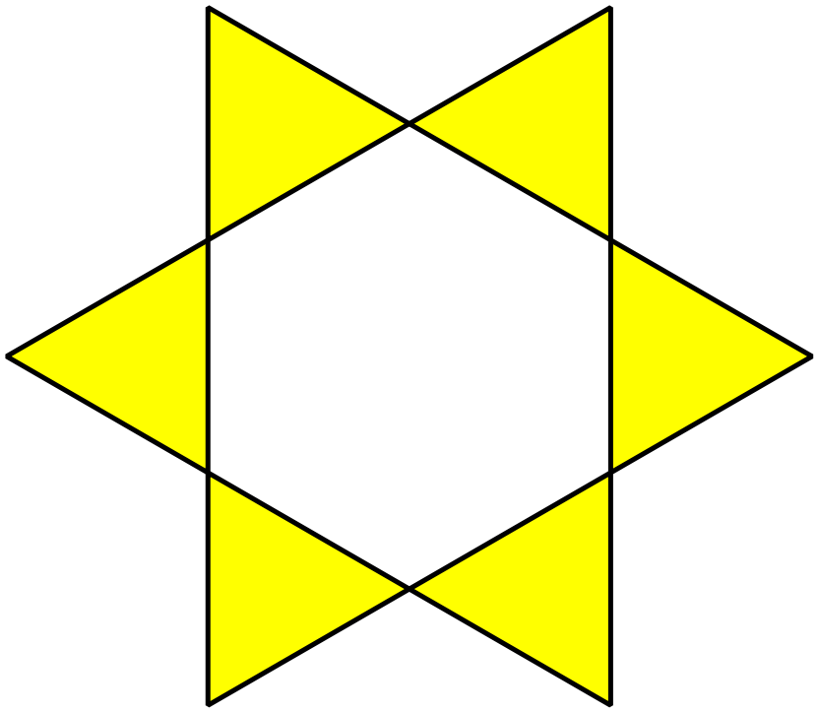What order of rotational symmetry does this shape have?

……………………………………………………………………..
Name the two angles which are shaded in the diagram below.
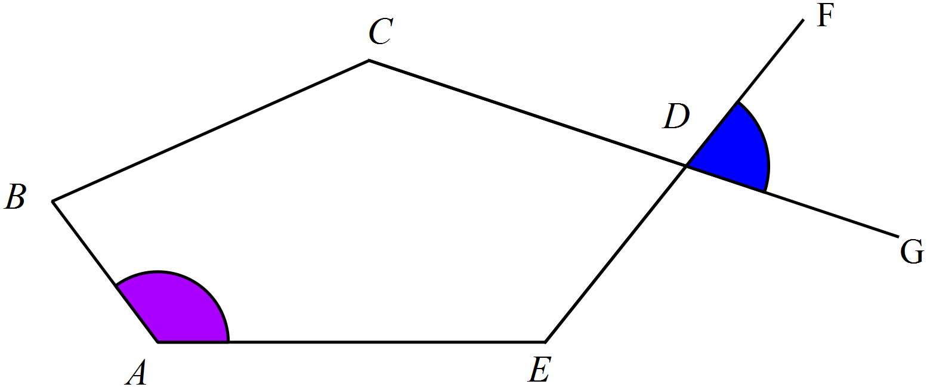

……………………………………………………………………..

……………………………………………………………………..
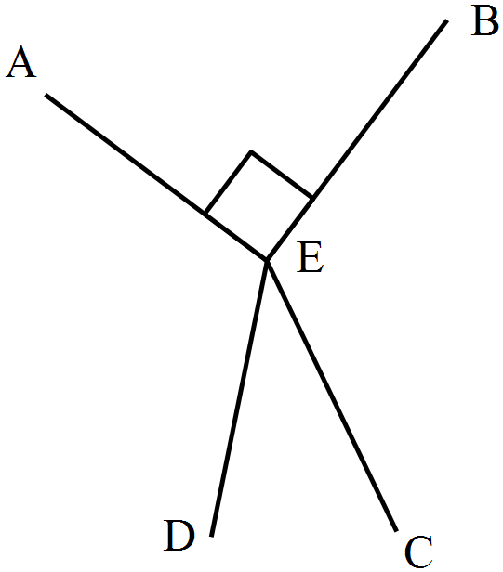Name an acute angle in the diagram below.

………………………………………………
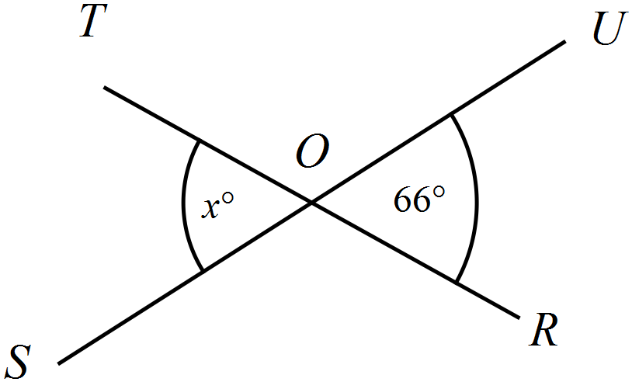Find the value of x.

………………………………………………

……………………………………………….
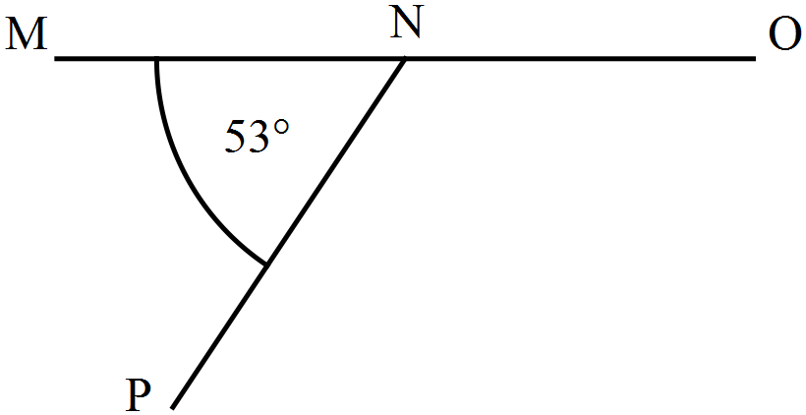Find the size of 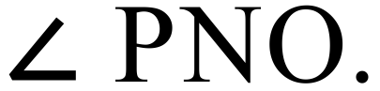

………………………………………………

……………………………………………….
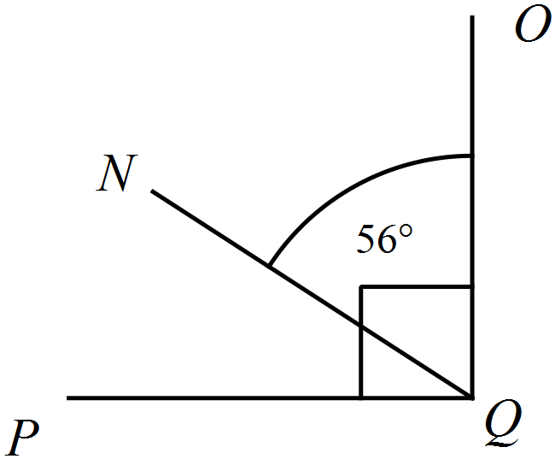Find the size of 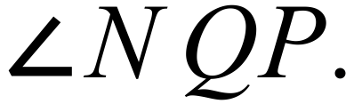

………………………………………………

……………………………………………….

………………………………………………
Find the value of x.
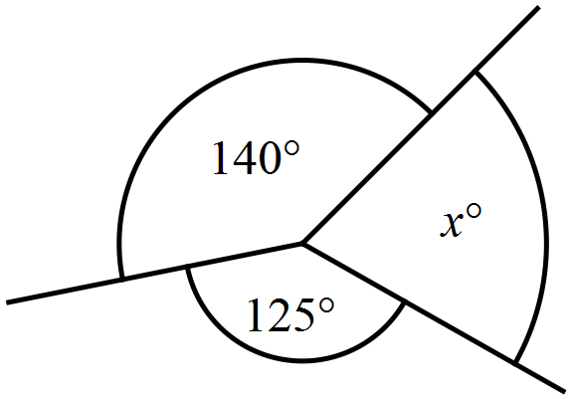
………………………………………………

……………………………………………….

………………………………………………
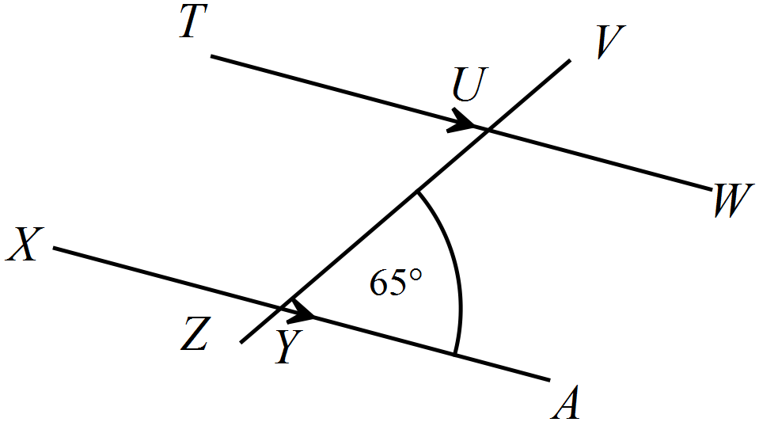Find the size of 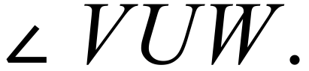

………………………………………………

……………………………………………….

……………………………………………….
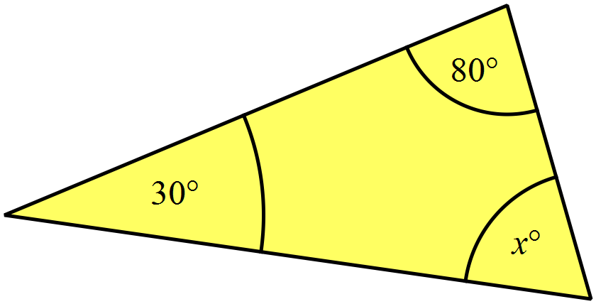Find the value of x.

………………………………………………

……………………………………………….

………………………………………………
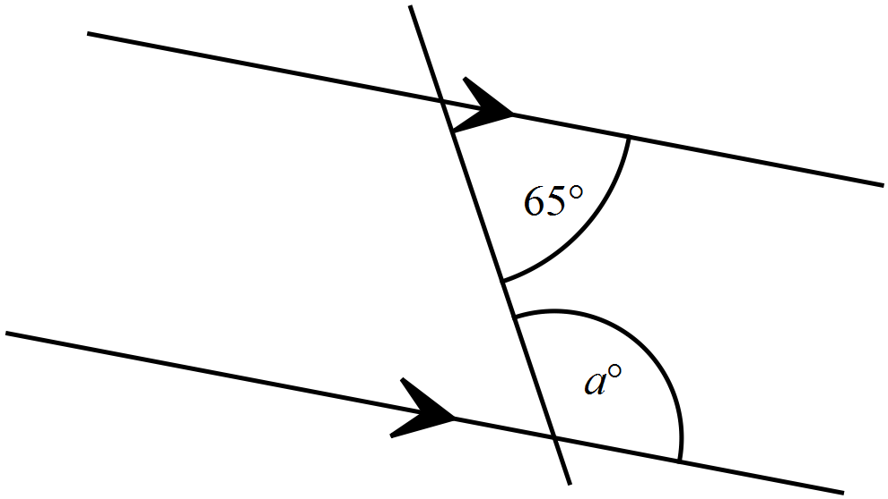Find the value of a.

..........................................................................

.........................................................................

.........................................................................
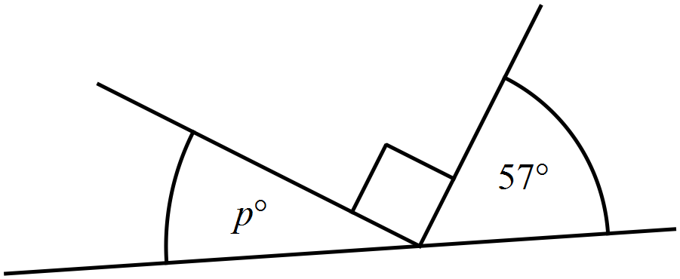Find the value of p.

..........................................................................

.........................................................................

.........................................................................
Use a protractor to draw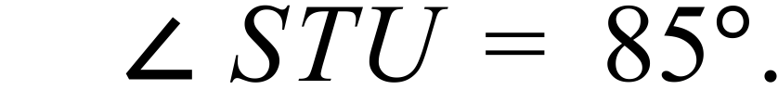

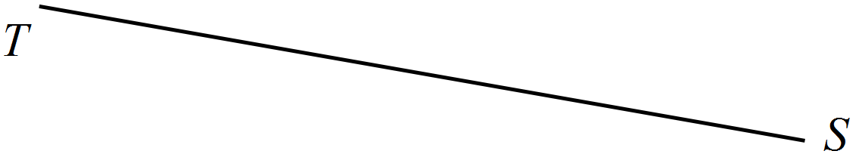

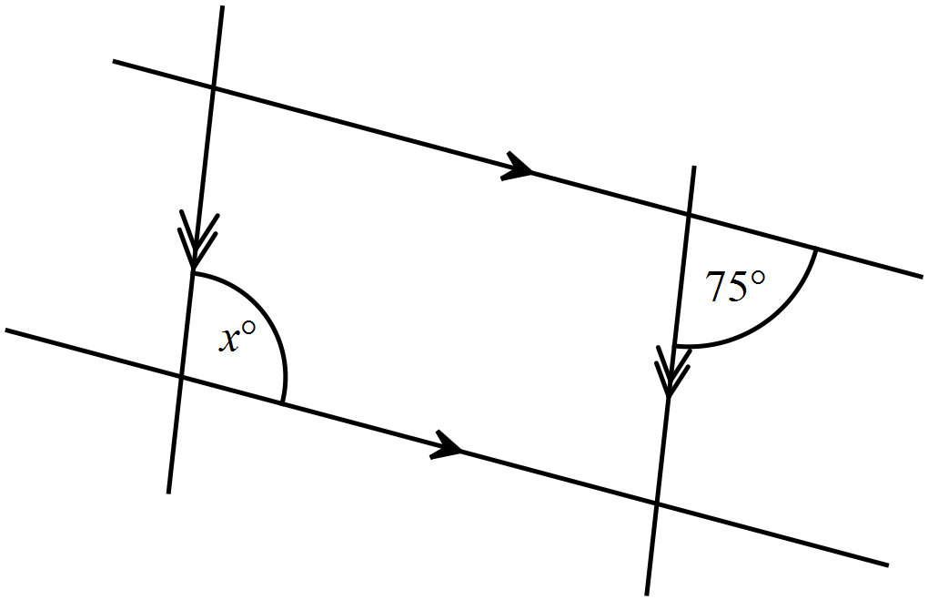Find the 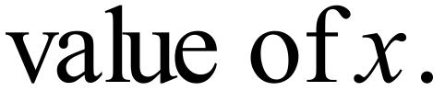

………………………………………………

……………………………………………….

………………………………………………
What is the value of b?
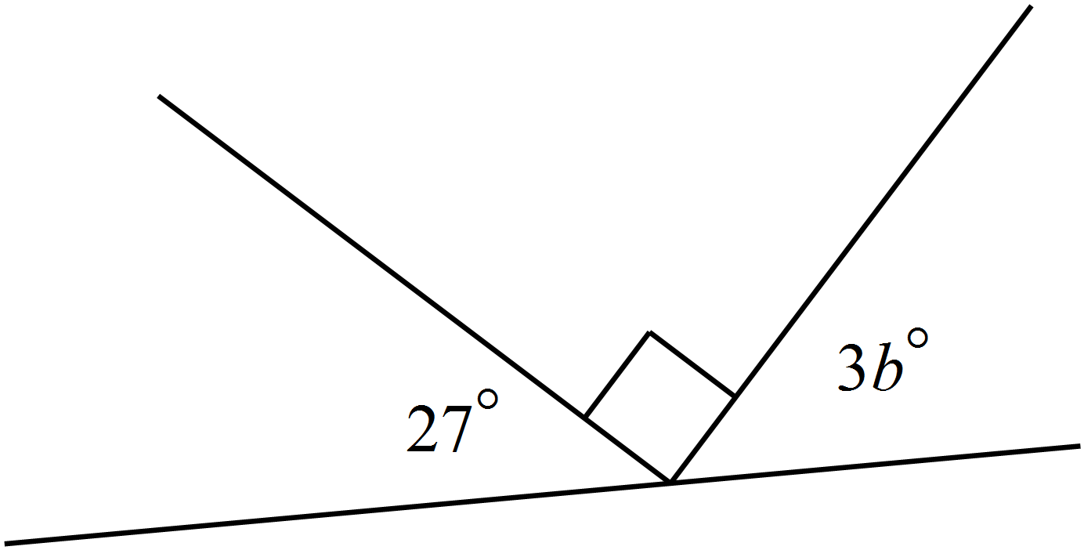

.........................................................................

..........................................................................

.........................................................................
Use the grid provided to draw 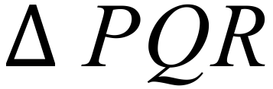 which is a right isosceles triangle.
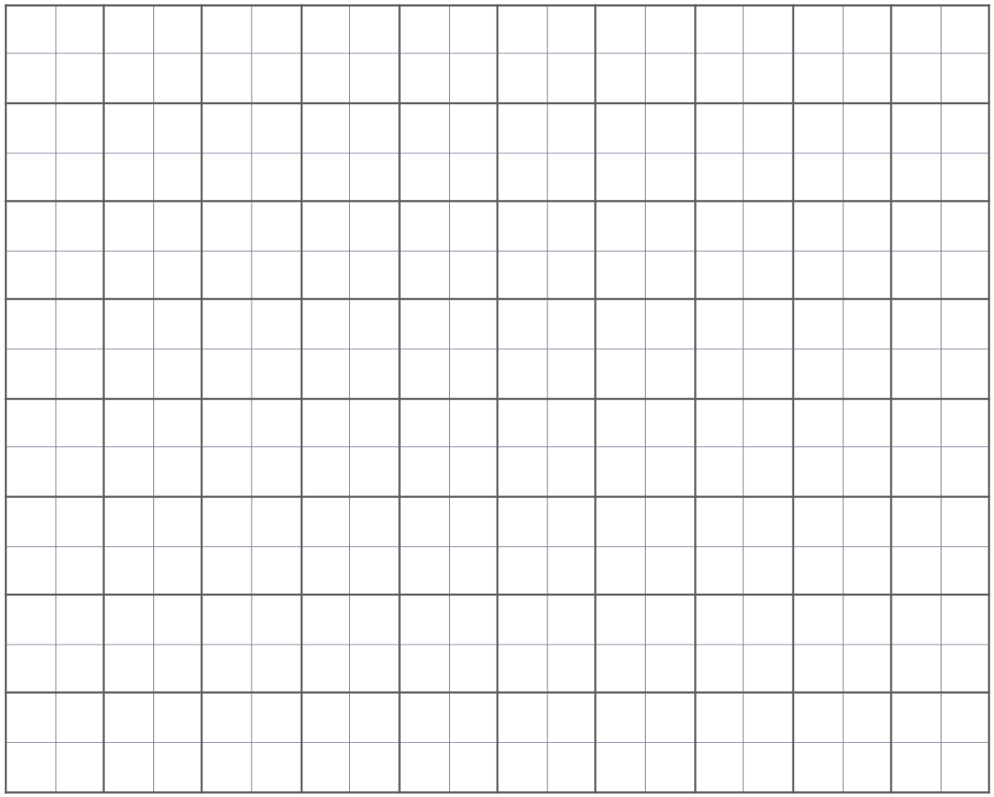

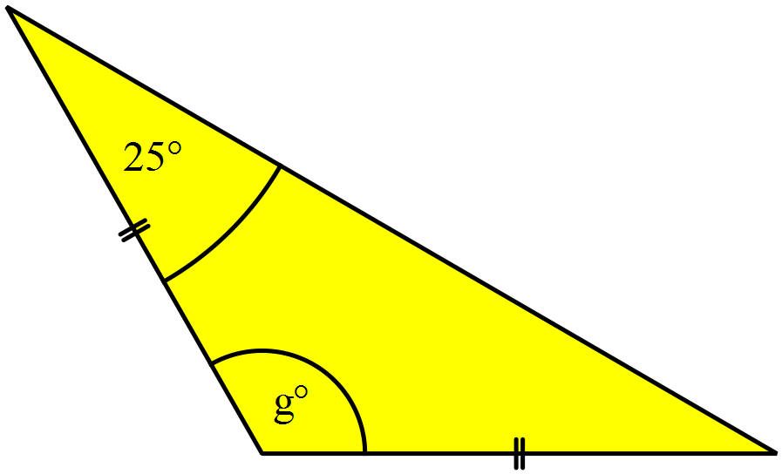Find the value of g.

………………………………………………

………………………………………………

……………………………………………….
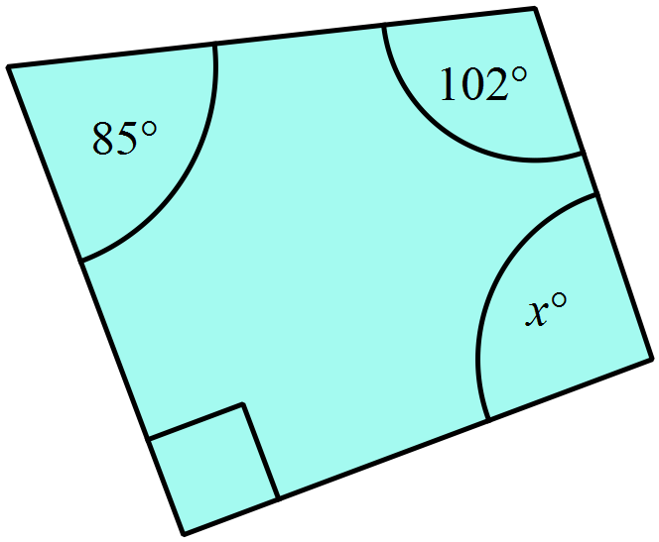Find the value of x.

………………………………………………

……………………………………………….

………………………………………………
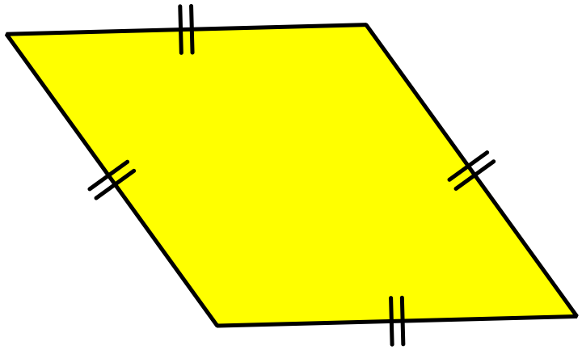What name could be used to describe the quadrilateral shown?

………………………………………………
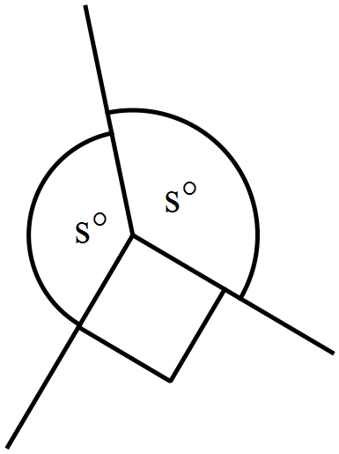Find the value of s.

.........................................................................

..........................................................................

........................................................................
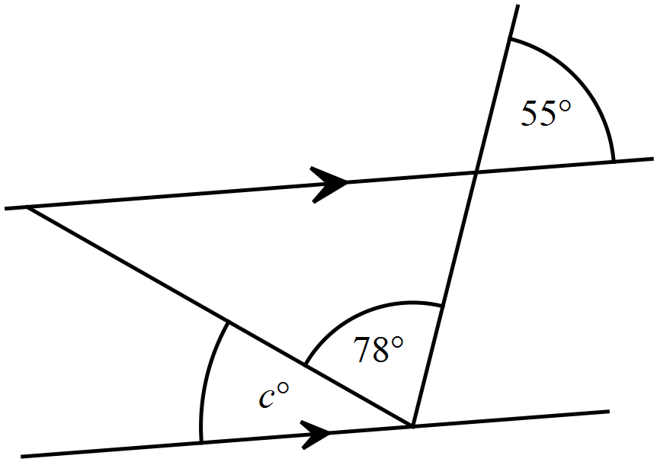Find the value of c.

..........................................................................

.........................................................................

.........................................................................
GDHI is a trapezium and HEFI is a parallelogram.
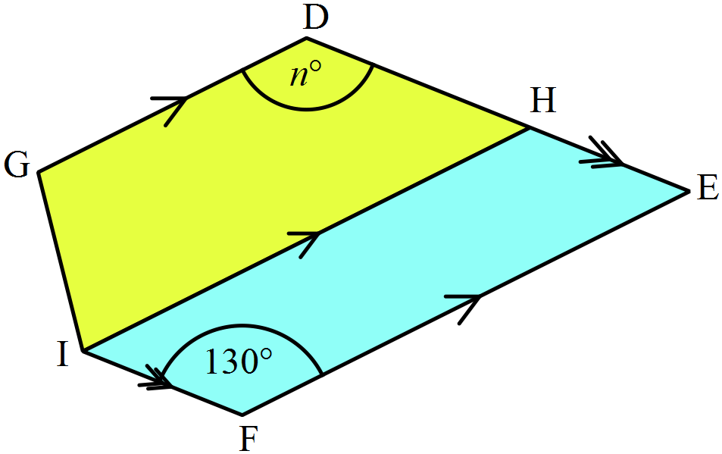DE is a straight line segment.
Find the value of n.

………………………………………………

……………………………………………….

………………………………………………
What is the value of x?

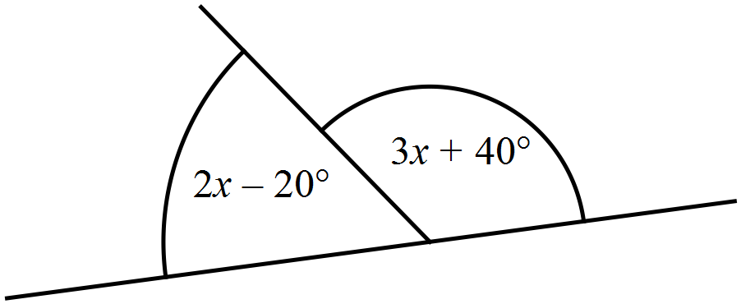
.........................................................................

..........................................................................

.........................................................................
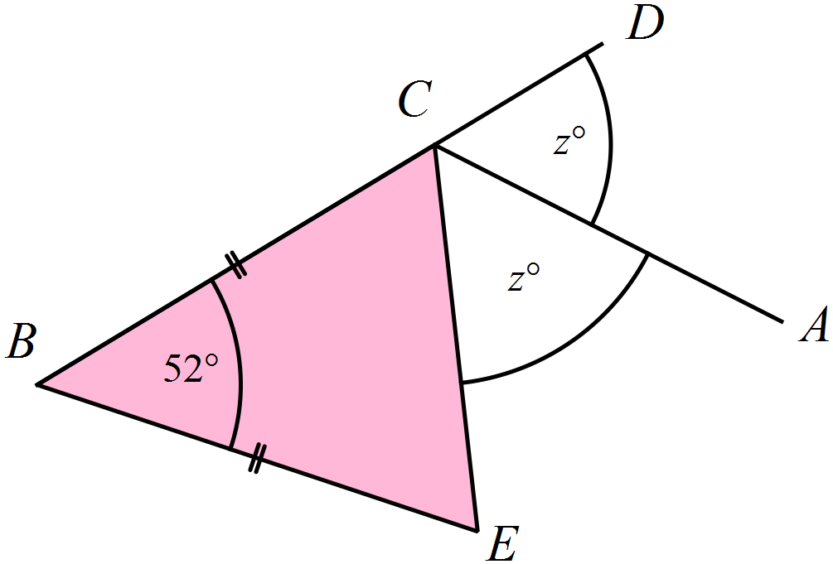BC = BE.
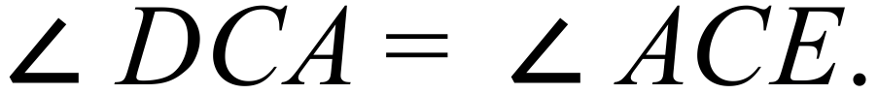
Find the value of z.

.........................................................................

..........................................................................

.........................................................................

.........................................................................
Find the value of h.

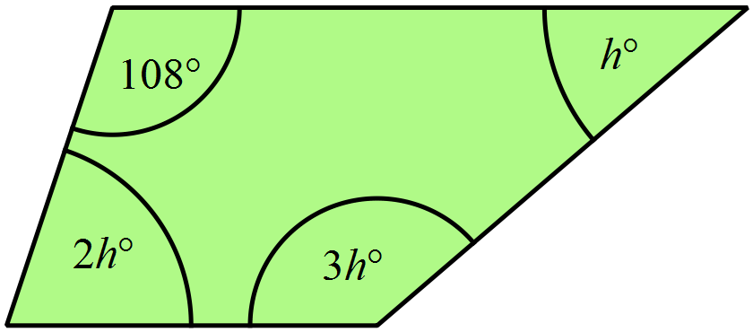

………………………………………………

……………………………………………….

………………………………………………
An irregular pentagon is shown.
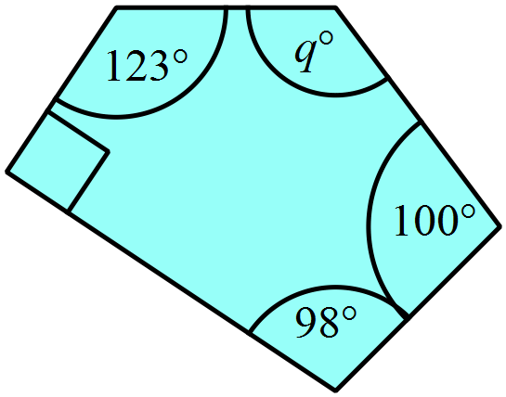What is the value of q?

.........................................................................

..........................................................................

.........................................................................
Complete the missing spaces in the table of properties of quadrilaterals, by placing a tick or a cross in the appropriate spaces.

PROPERTY | Square | Parallelogram | Rectangle
Diagonals are perpendicular
Diagonals bisect one another.

Year 9 |  | Basic Geometry | Calculator Allowed
 |  | Basic Geometry | Name_________________
Section 2 Multiple Choice Section
Mark all your answers on the accompanying multiple choice answer sheet, not on this test paper. You may do any working out on this test paper. Calculators are allowed for this section.
DIAGRAMS ARE NOT TO SCALE UNLESS OTHERWISE STATED
 | 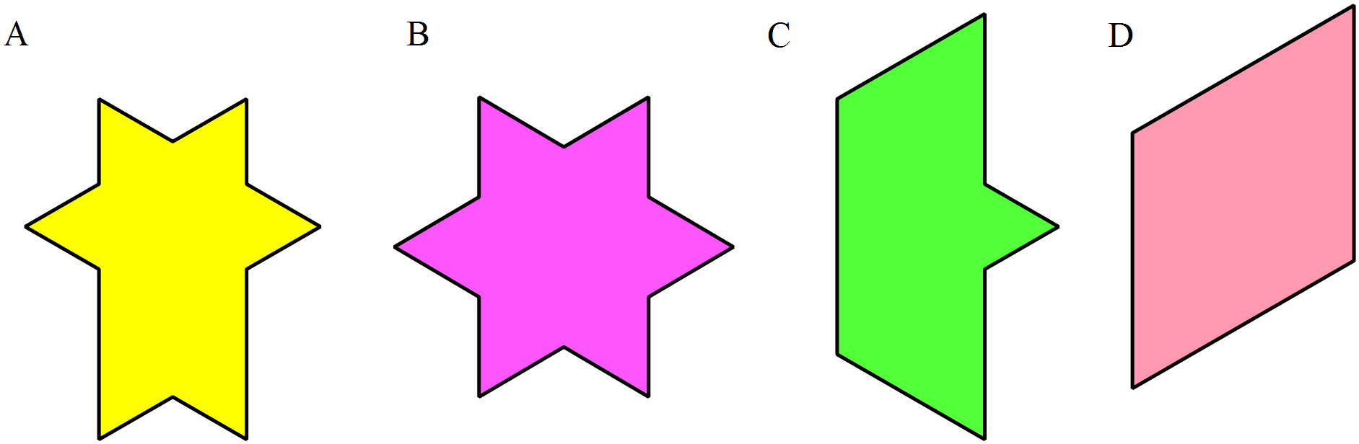Which of the shapes shown has rotational symmetry but no line symmetry?
What are the names of the quadrilaterals that are used to make this design?
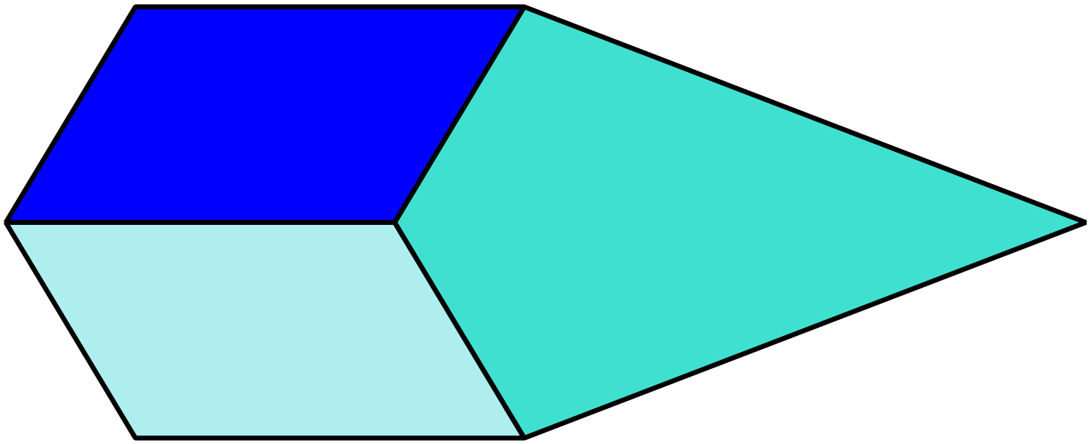

A. Kite and parrallelogram.
B. Kite and rhombus.
C. Parralelogram and rhombus.
D. Rectangle and Rhombus.
Which diagram includes a pair of vertically opposite angles 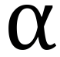 and 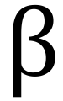 ?
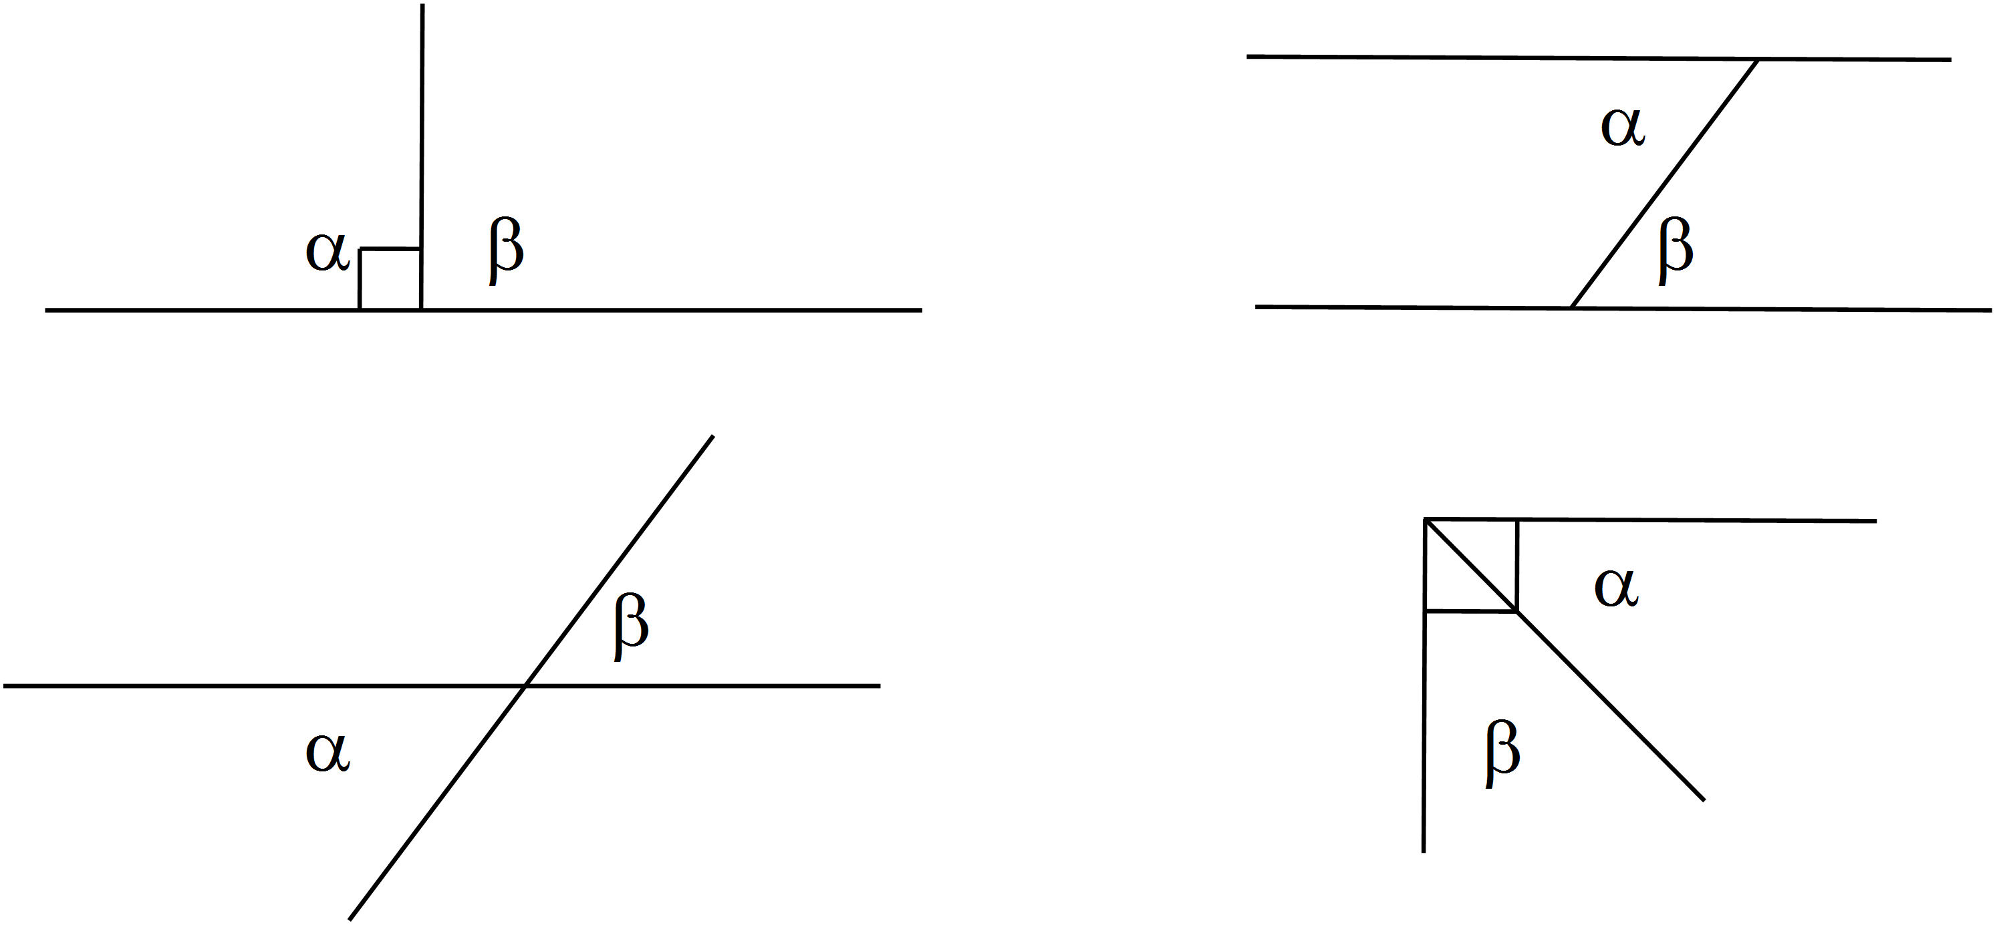 A. B.

C. D.

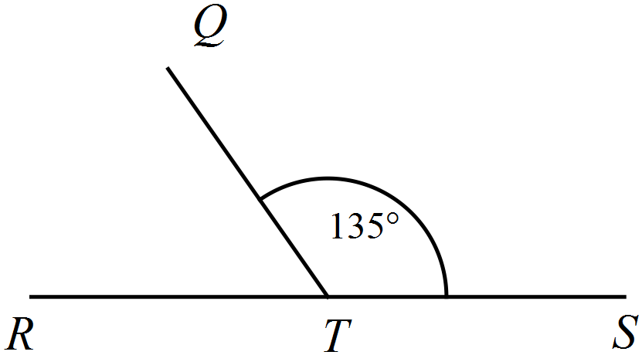What is the size of 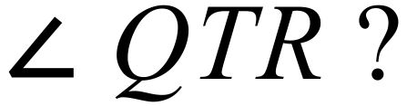

A. 35º.
B. 45º
C. 55º.
D. 65º.

Which figure shows an obtuse scalene triangle? (These figures are to scale)
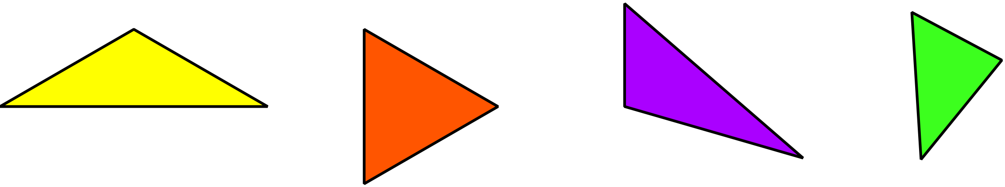 A. B. C. D.

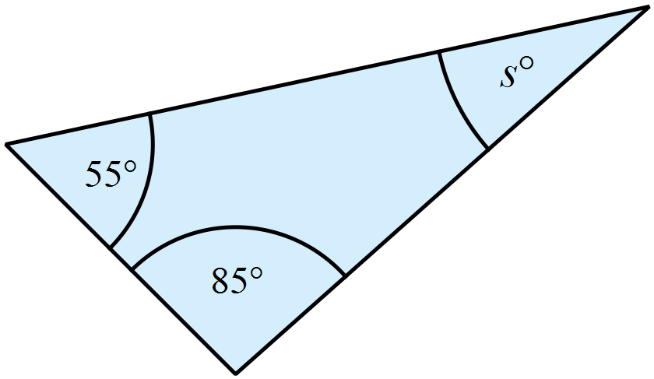What is the value of s?

A. s = 30º
B. s = 35º
C. s = 40º
D. s = 45º

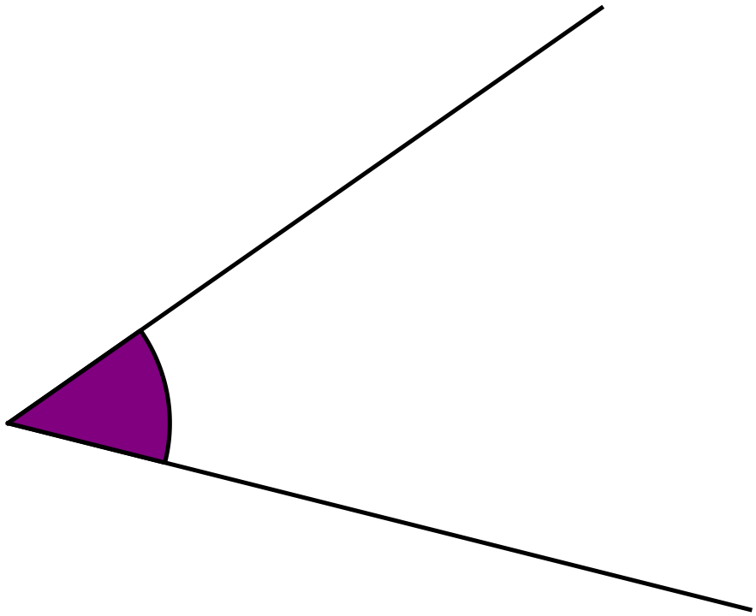Measure the size of 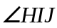 with a protractor.

A. 39º
B. 41º
C. 44º
D. 49º

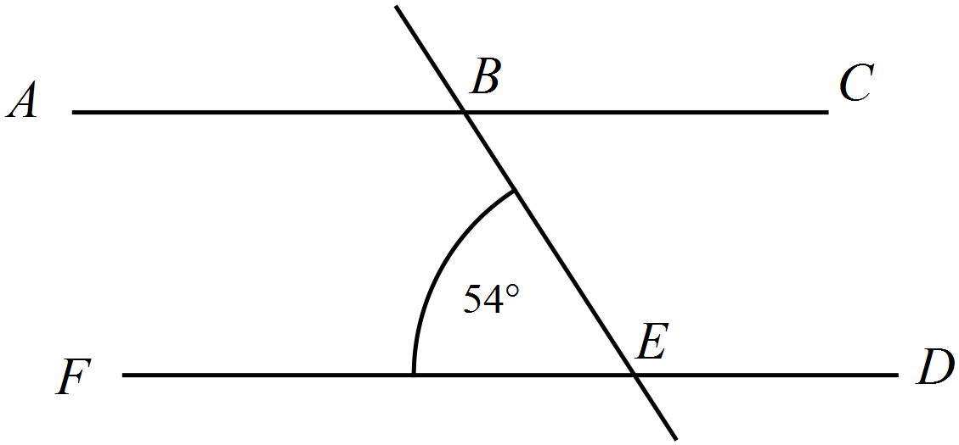What is the size of 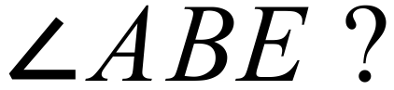

A. 36º
B. 54º
C. 116º
D. 126º
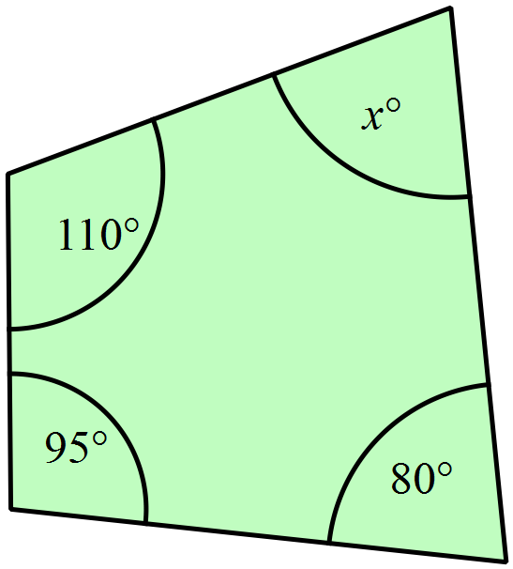What is the value of x?

A. x = 25
B. x = 65
C. x = 75
D. x = 125

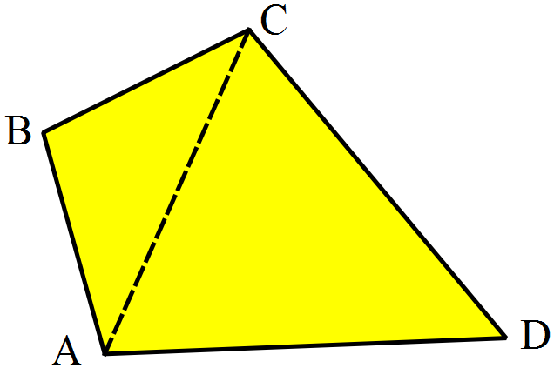 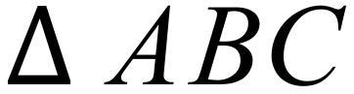 and 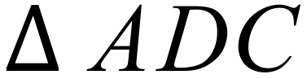 are non-congruent isosceles triangles.
What type of quadrilateral is ABCD?

A. A kite.
B. A parallelogram.
C. A rhombus
D. A trapezium.
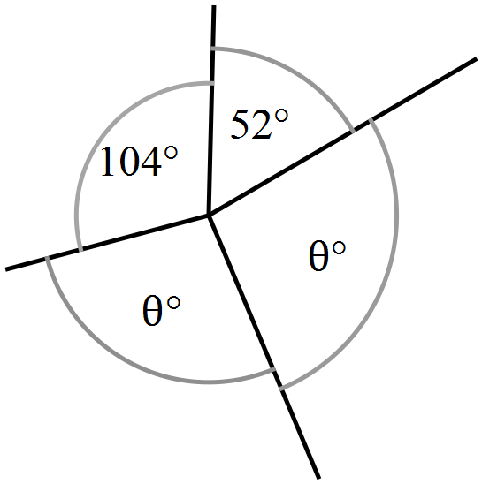What is the value of 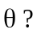

A. 24
B. 102
C. 156
D. 204

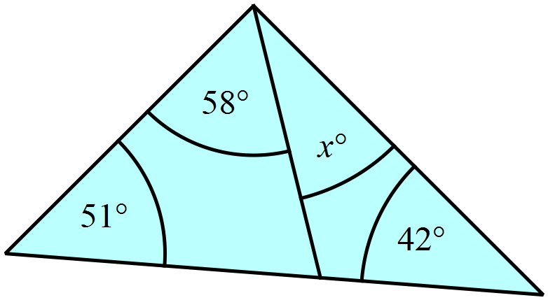What is the value of x?

A. x = 29
B. x = 42
C. x = 45
D. x = 87

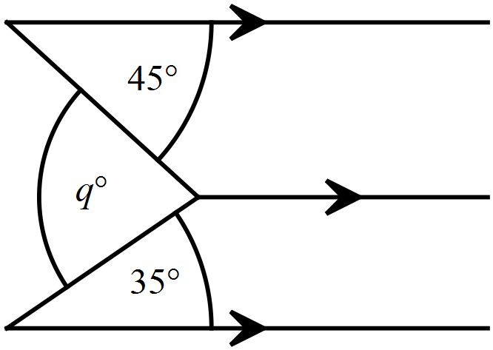Find the value of q.

A. q = 45
B. q = 70
C. q = 80
D. q = 85
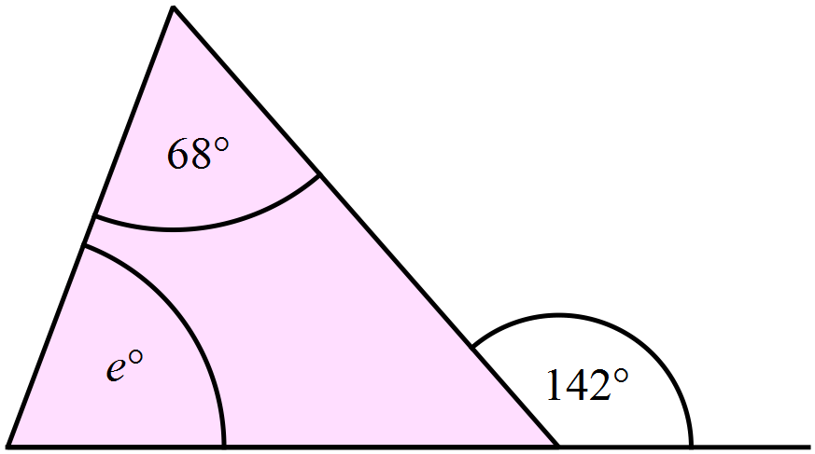The value of e in the diagram below is:

A. e = 68 B. e = 74 C. e = 80 D. e = 210
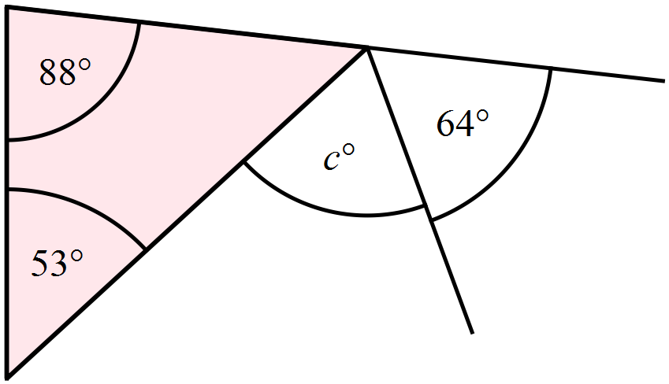Find the value of c.

A. 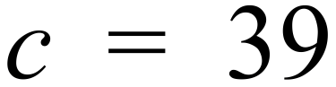
B. 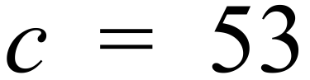
C. 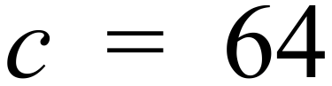
D. 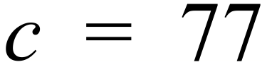

Which two quadrilaterals both have the property below?
Both diagonals bisect one another at right angles.
A. A kite and a square
B. A kite and a parallelogram.
C. A rectangle and a rhombus.
D. A rhombus and a square.
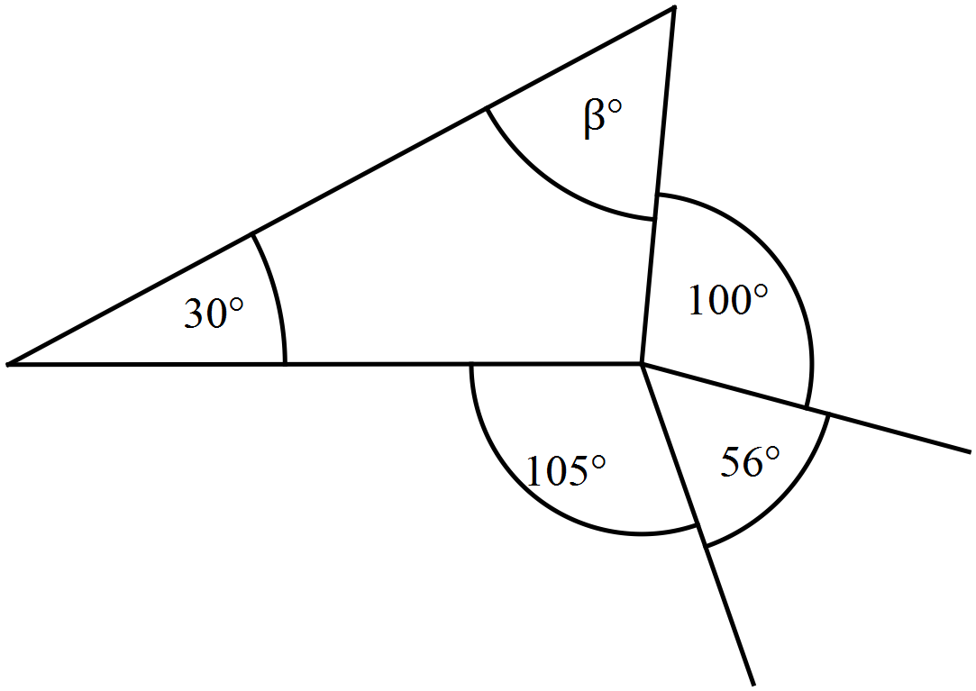What is the value of 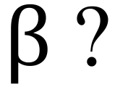

A. 51
B. 99
C. 129
D. 261
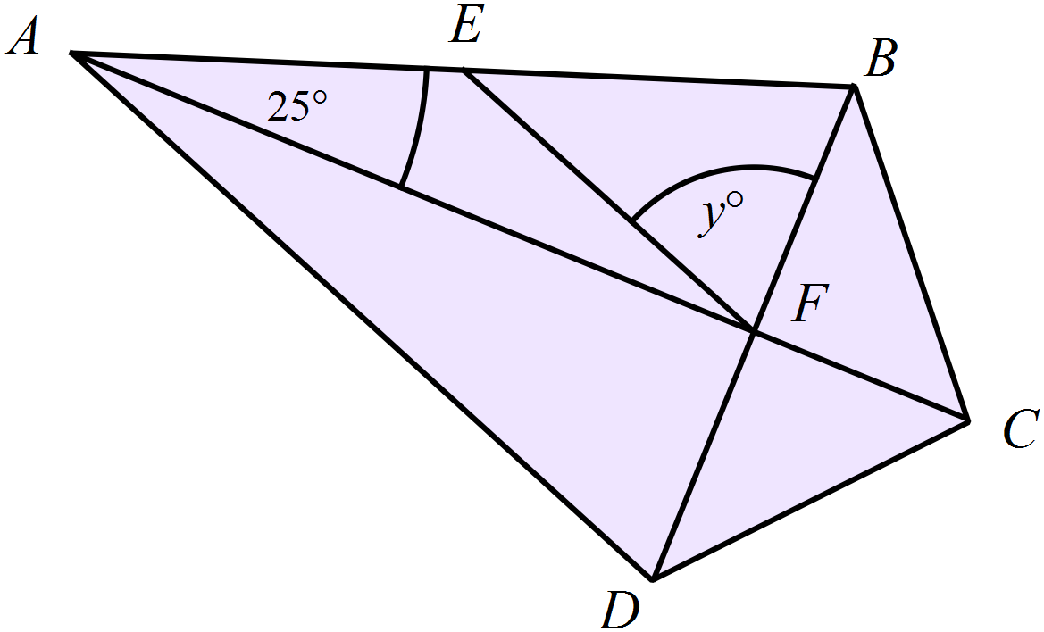ABCD is a kite whose diagonals intersect at F.
E is a point on AB such that AE = EF.
What is the value of y?
A. 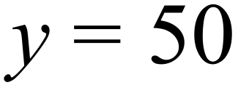
B. 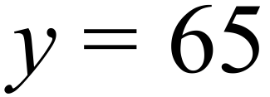
C. 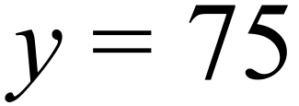
D. 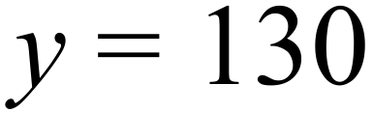
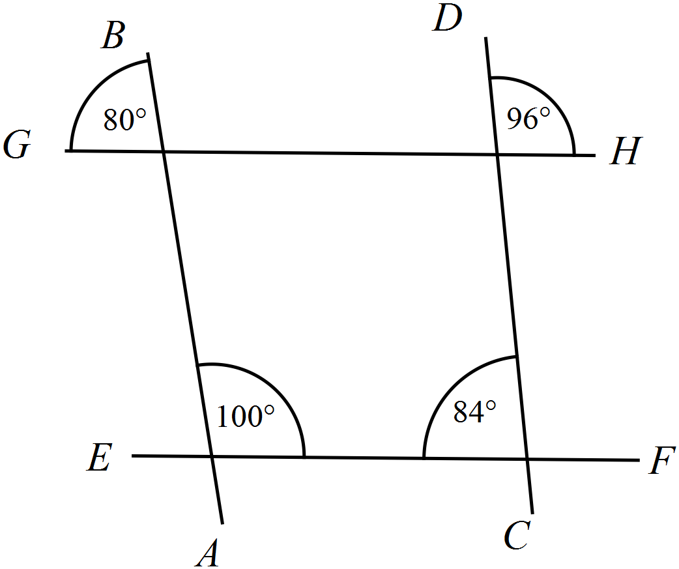Which lines are parallel?

A. 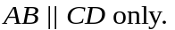
B. 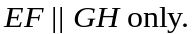
C. 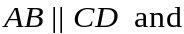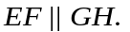
D. No lines are parallel.

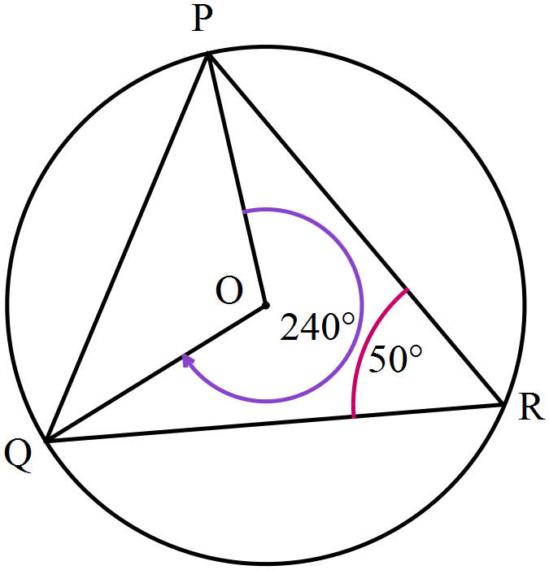PQ and R are points on a circle, centre O.
PO and QO are radii and PR = QR .
What is the size of 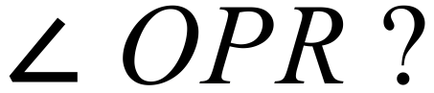 ?

A. 35 º
B. 45 º
C. 65 º
D. 130º

Year 9 | Basic Geometry | Calculator Allowed
Year 9 | Basic Geometry | Name___________________
Section 3 Longer Answer Section
Write all working and answers in the spaces provided on this test paper.

 |  | Marks
1. | Complete the following using geometric instruments.  Do not erase any of your construction lines.
 | - 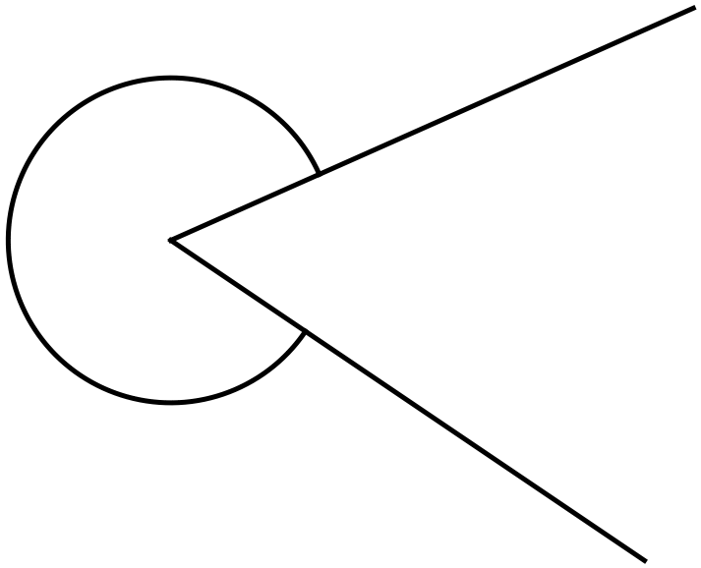 Use a protractor to help determine the size of the reflex angle marked below. | 1
 | - Draw a right angled triangle which has one angle equal to 56º. | 2
2. | Complete the following using geometric instruments.  Do not erase any of your construction lines.
 | - Draw a line which passes through N and is perpendicular to LM.  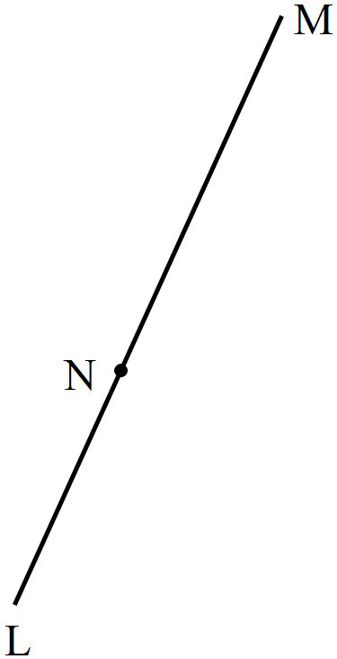 | 2
 | - Draw a rhombus which has 6 cm sides and an internal angle of 125º. | 2

Multiple Choice Answer Sheet
Basic Geometry
Name _____________________________________________
Completely fill the response oval representing the most correct answer.

1. A B C D
2. A B C D
3. A B C D
4. A B C D
5. A B C D
6. A B C D
7. A B C D
8. A B C D
9. A B C D
10. A B C D
11. A B C D
12. A B C D
13. A B C D
14. A B C D
15. A B C D
16. A B C D
17. A B C D
18. A B C D
19. A B C D
20. A B C D
Year 9 |  | Basic Geometry | Non Calculator
Section 1 Short Answer Section
ANSWERS
No. | WORKING |  | ANSWER
 | Order 6 as each point can be rotated to the next to look the same. |  | Order 6
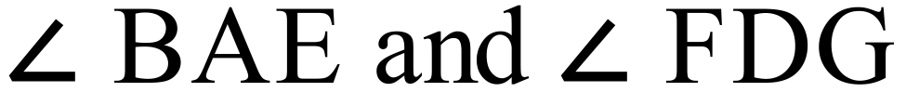
or in reverse order.
 |  |  | 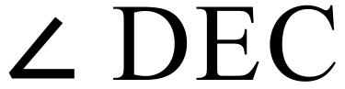 or 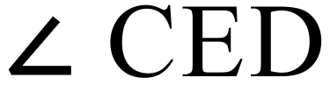
 | Vertically opposite angles |  | x = 66
 | 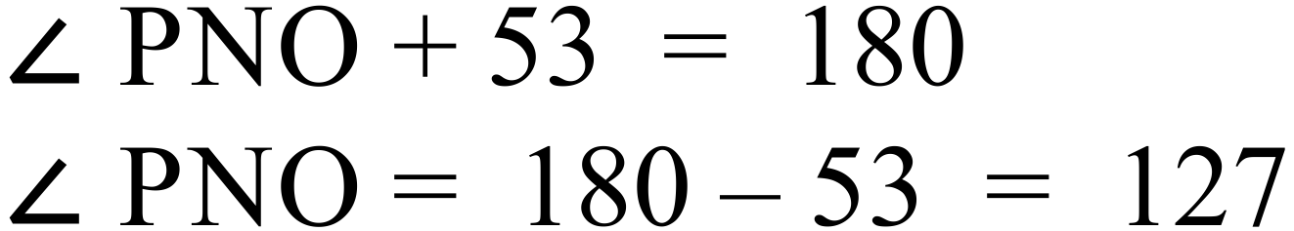  (Supplementary Angles on Straight Line) |  | 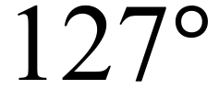
 | 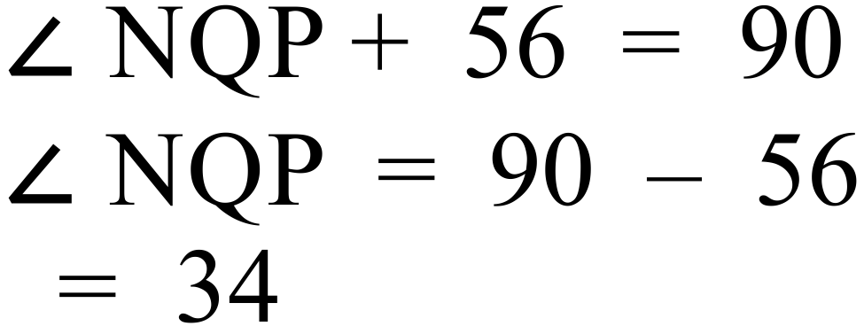(Complementary Angles) |  | 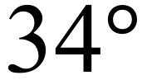
 | 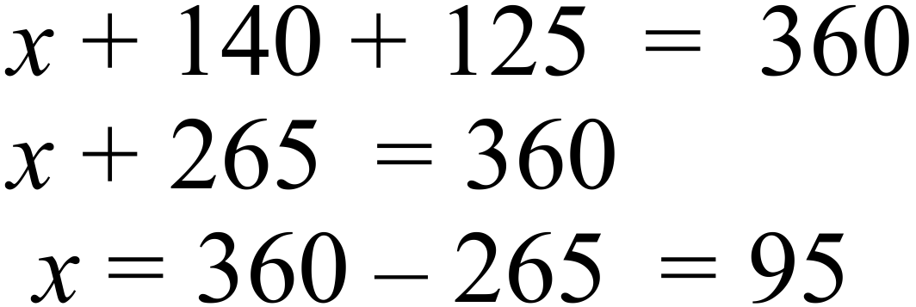 (Angles at a point) |  | 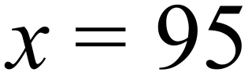
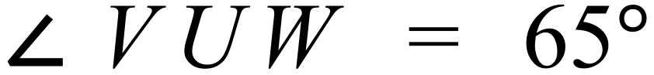
Corresponding angles on || lines are equal
 | 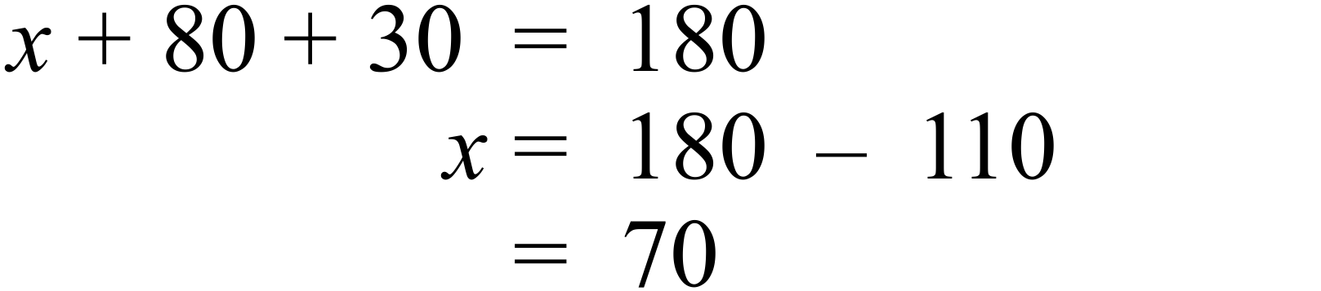 (Angle sum of triangle) |  | 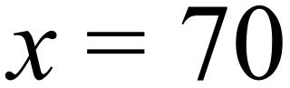
 | 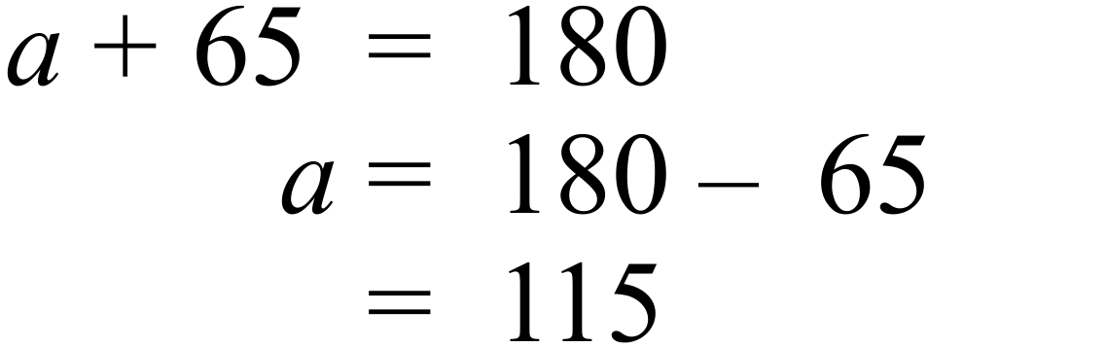  (Cointerior angles are supplementary on || lines) |  | 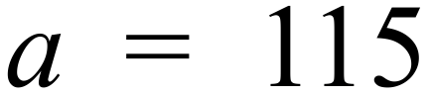
 | 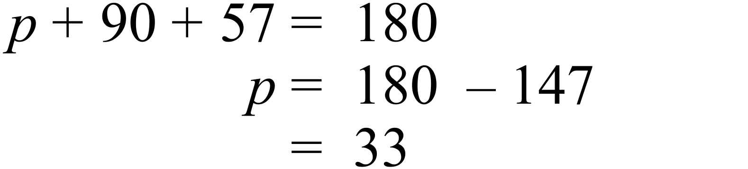  (Supplementary Angles on Straight Line) |  | 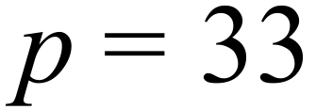
 | 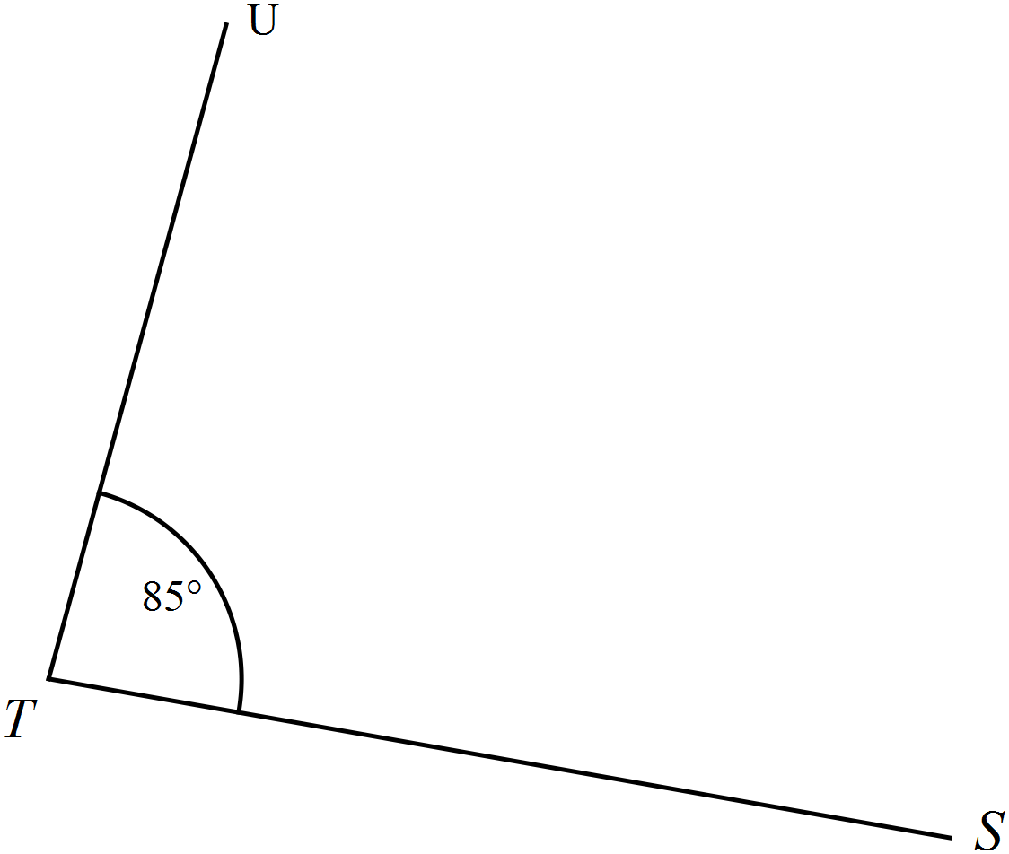 |  | See diagram
 | 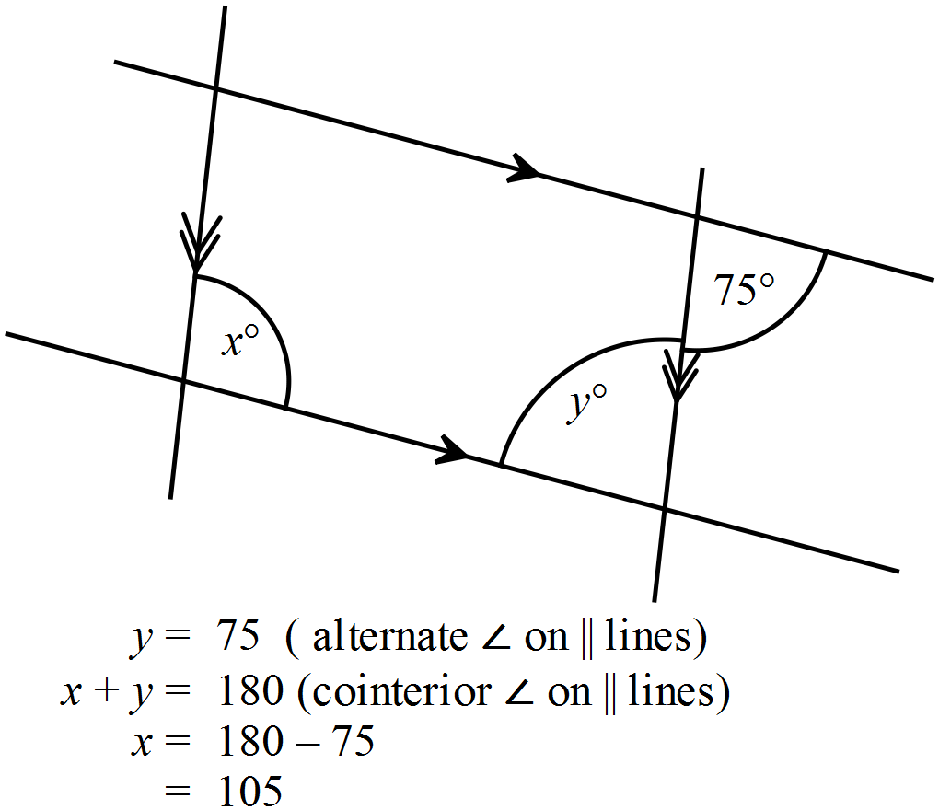 |  | 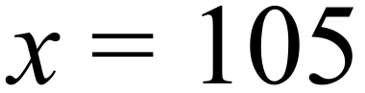
 | 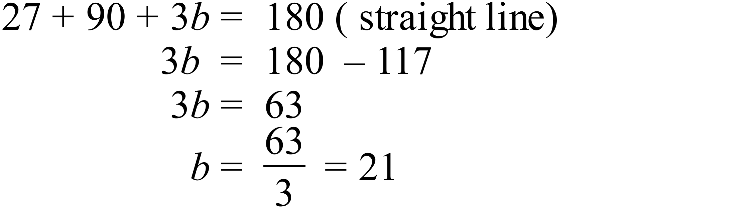 |  | 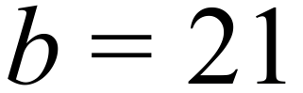
 | 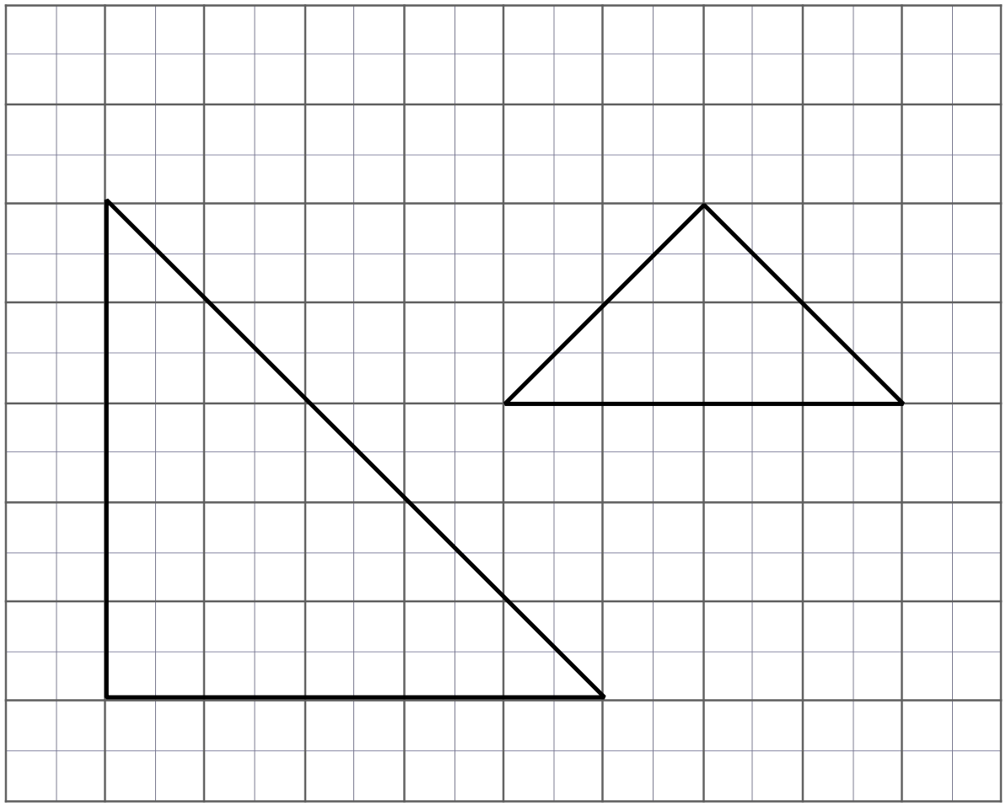 |  | Many possible triangles, two examples shown.
 | 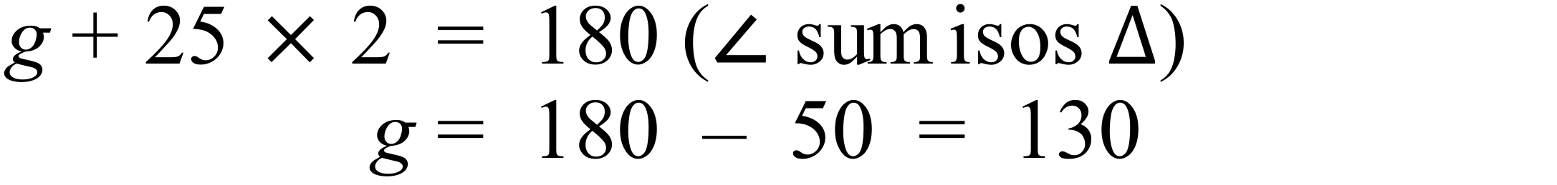 |  | 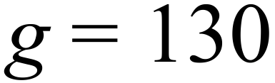
 | 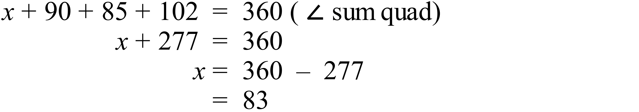 |  | 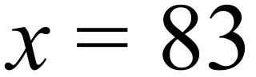
 | All sides are equal so it is a rhombus |  | Rhombus
 | 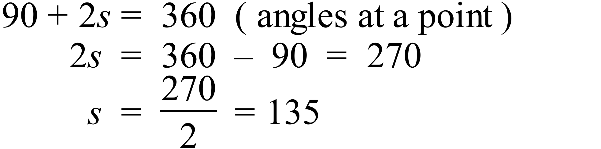 |  | 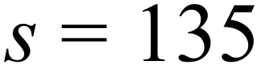
 | 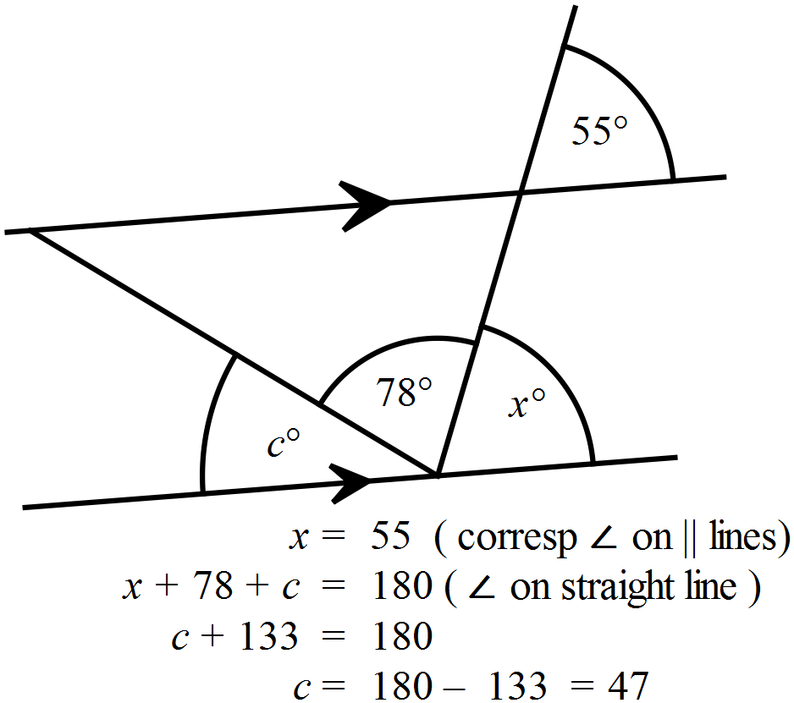 |  | 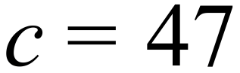
 | 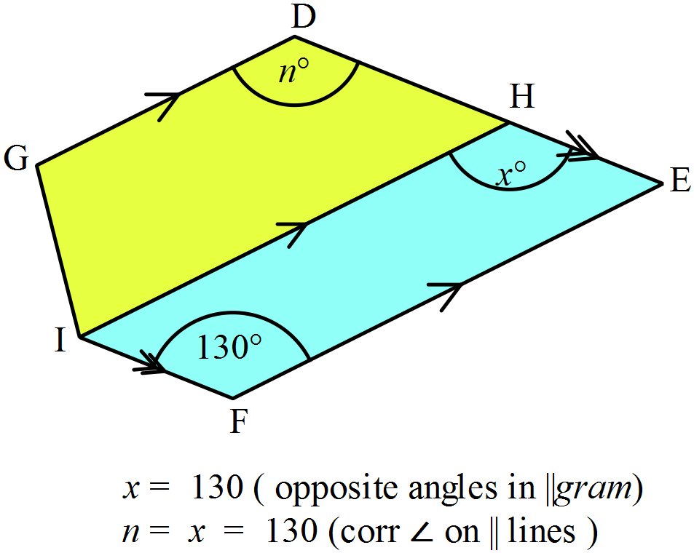 |  | 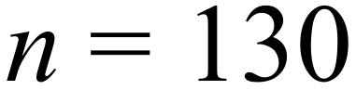
 | 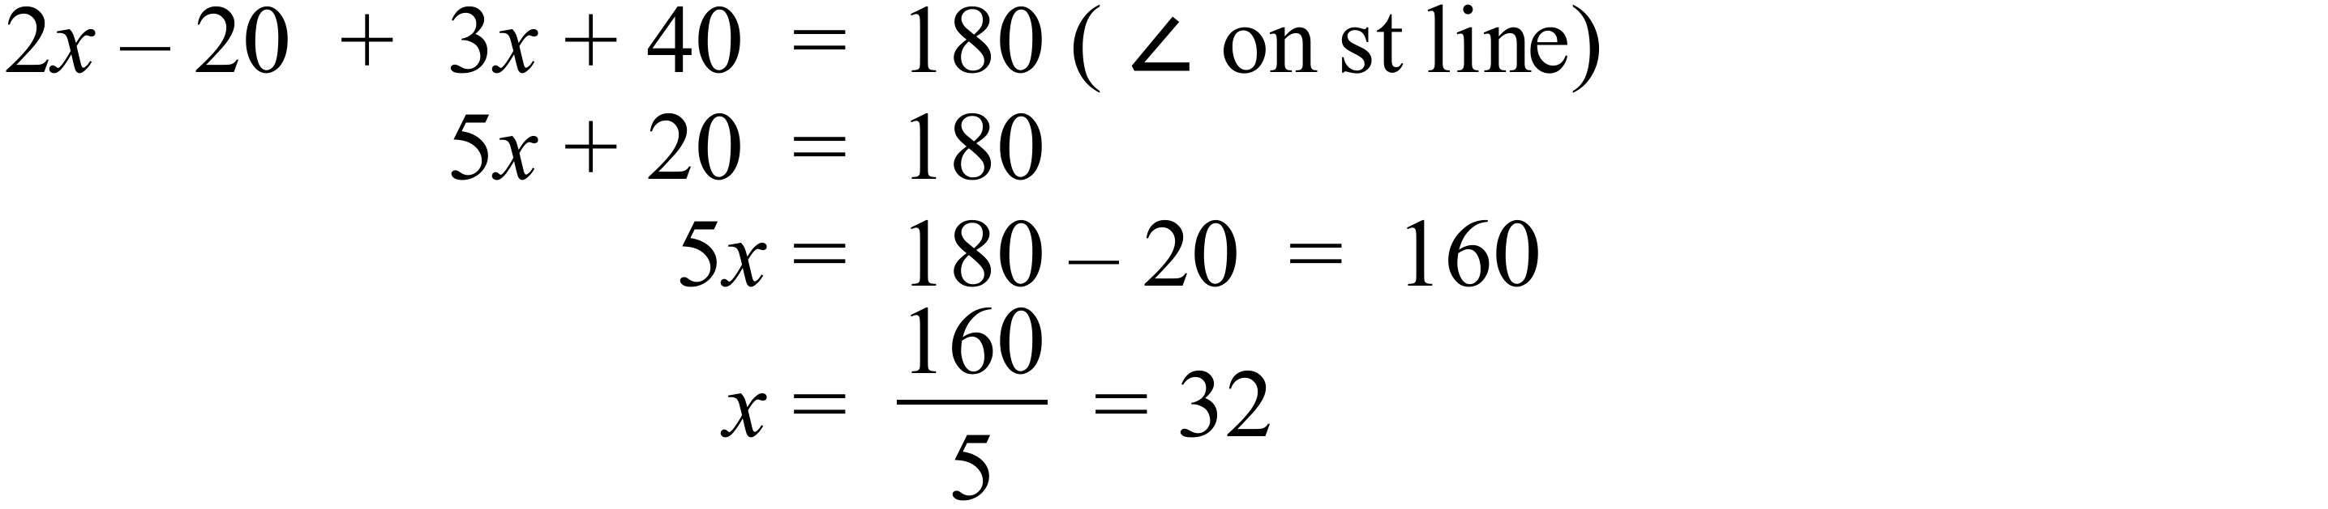 |  | 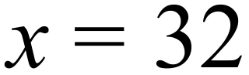
 | 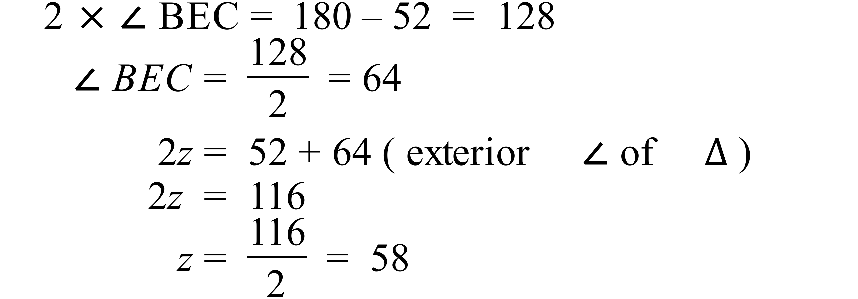 |  | 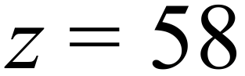
 | 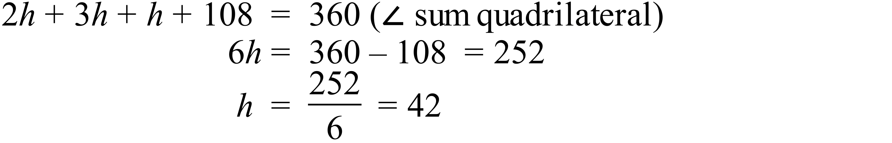 |  | 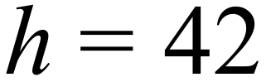
 | 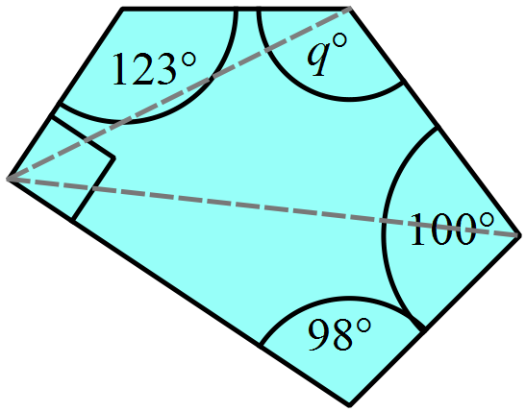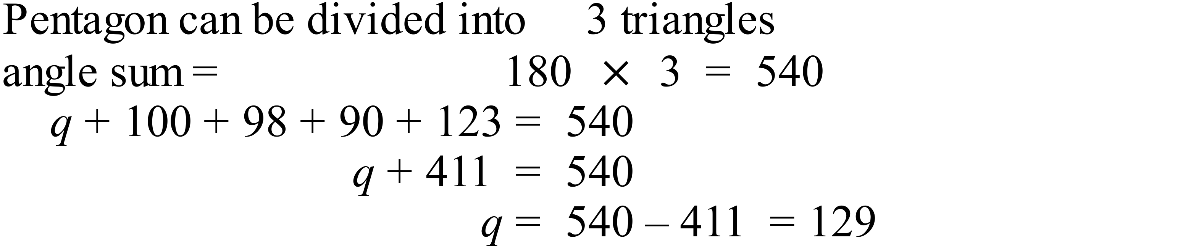 |  | 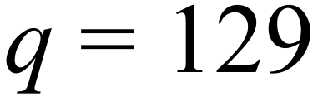
PROPERTY | Square | Parallelogram | Rectangle
Diagonals are perpendicular
Diagonals bisect one another.

Year 9 |  | Basic Geometry | Calculator Allowed
Section 2 Multiple Choice Section
ANSWERS
No. | WORKING |  |  | ANSWER
 | B and D have rotational symmetry but B also has line symmetry |  |  | D
 | Kite and Parallelogram |  |  | A
 | C are vertically opposite |  |  | C
 | 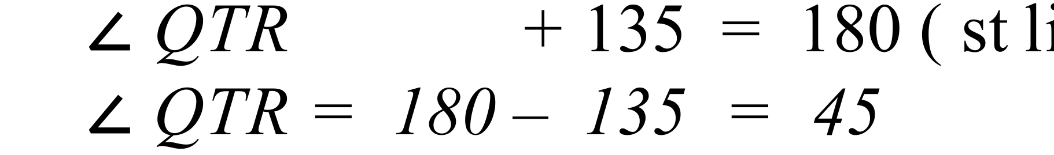 |  |  | B
 | C has all sides different and an obtuse angle |  |  | C
 | 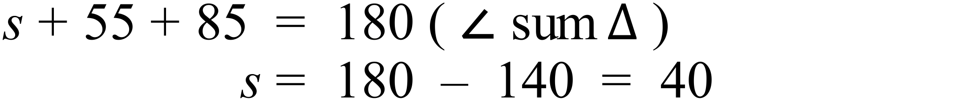 |  |  | C
 | 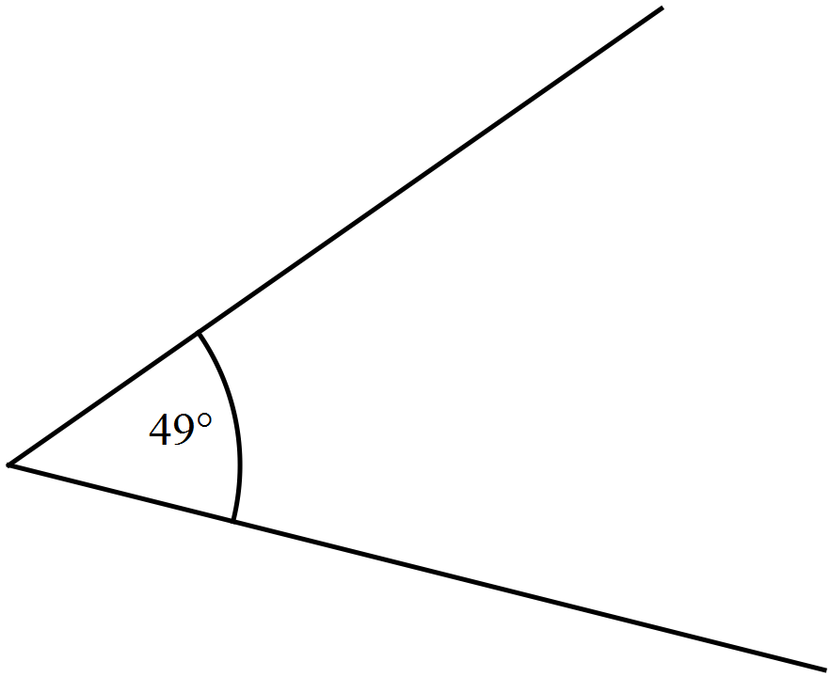 |  |  | D
 |  |  |  | D
 | 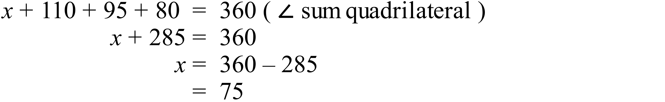 |  |  | C
 | 2 pairs of adjacent sides equal so it is a kite |  |  | A
 | 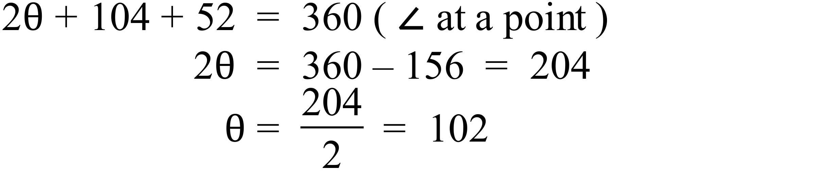 |  |  | B
 | 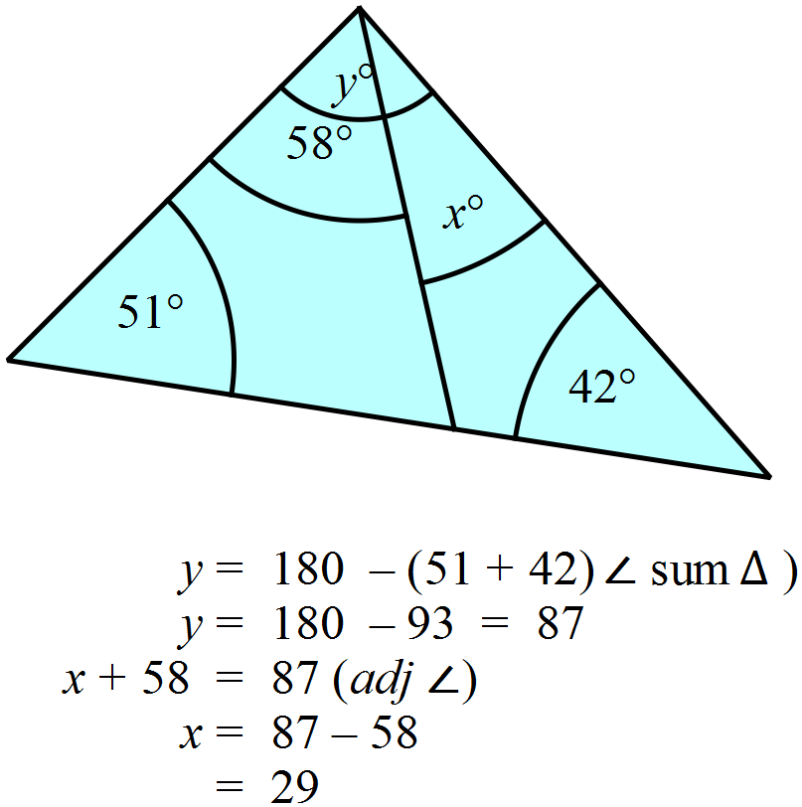 |  |  | A
 | 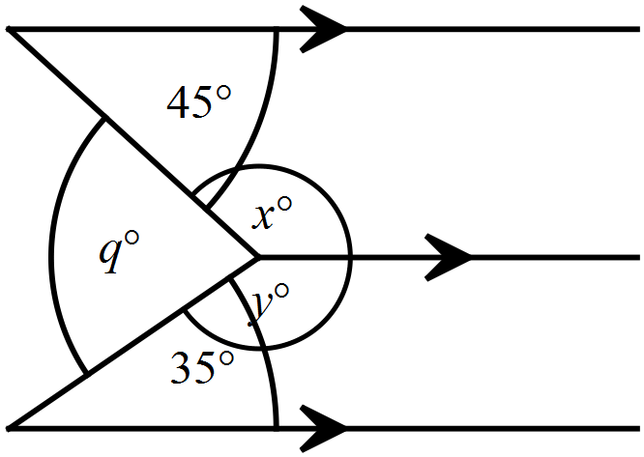  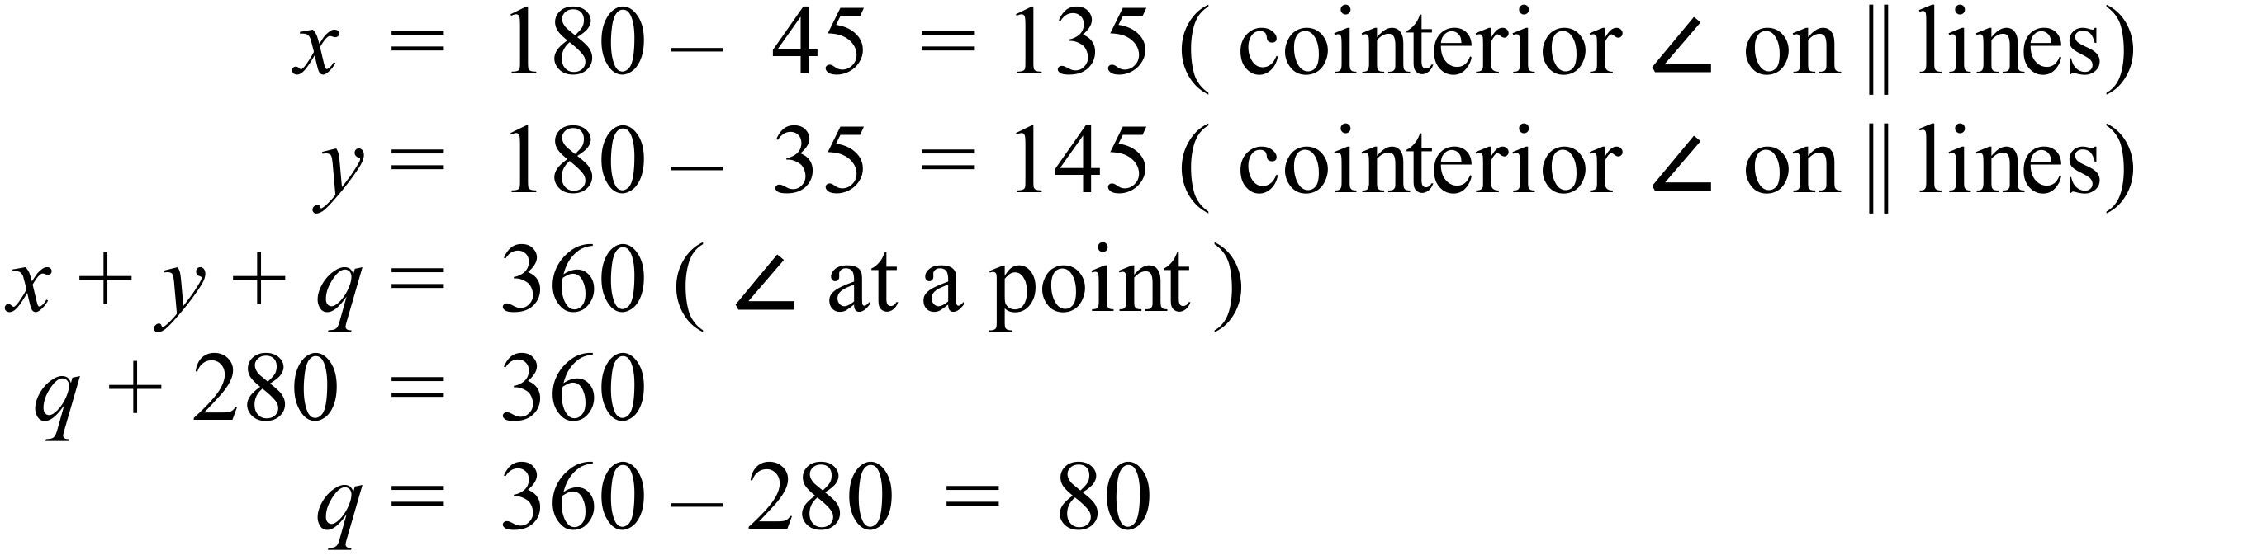 |  |  | C
 | 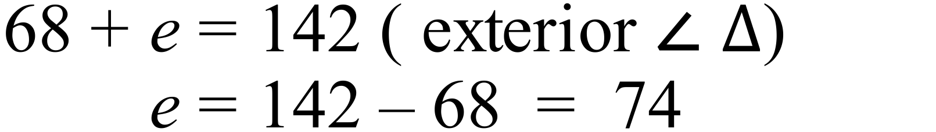 |  |  | B
 | 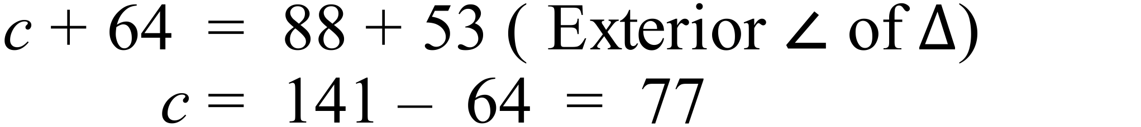 |  |  | D
 | Only the rhombus and square have both parts of the property |  |  | D
 | 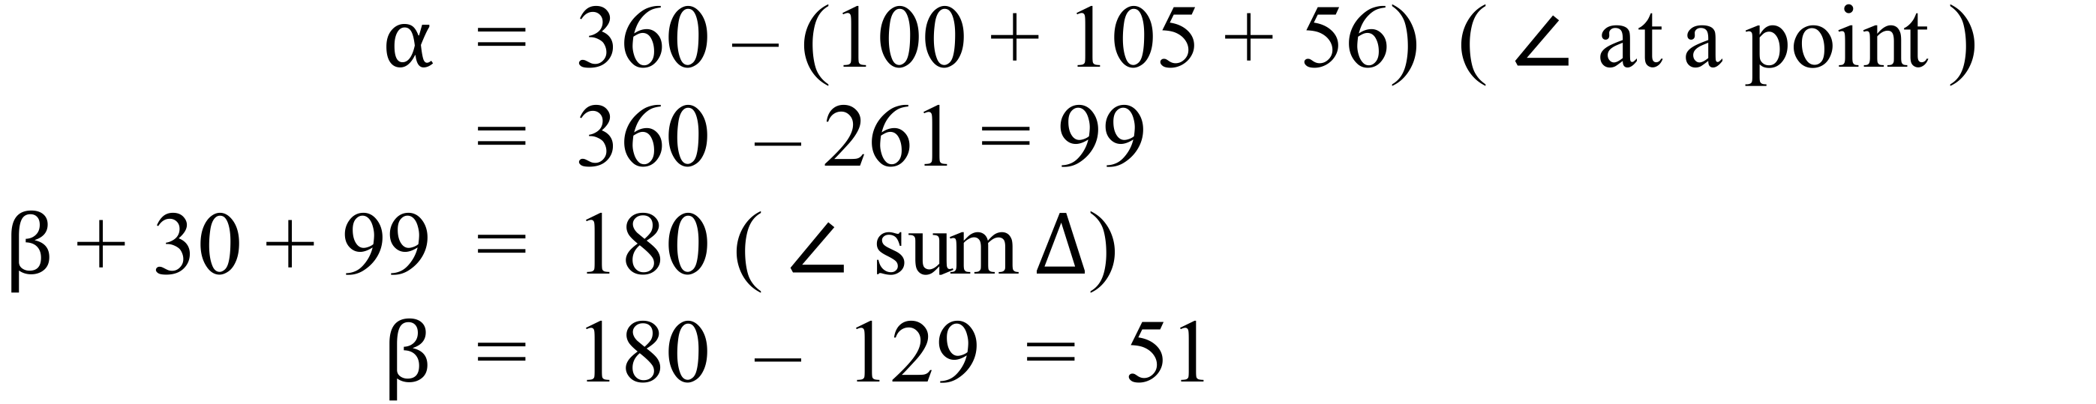 |  |  | A
 | 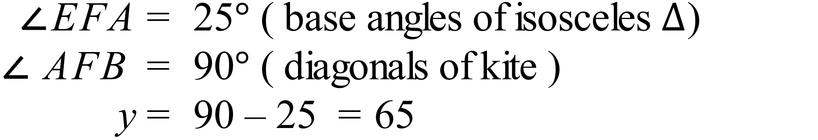 |  |  | B
 | 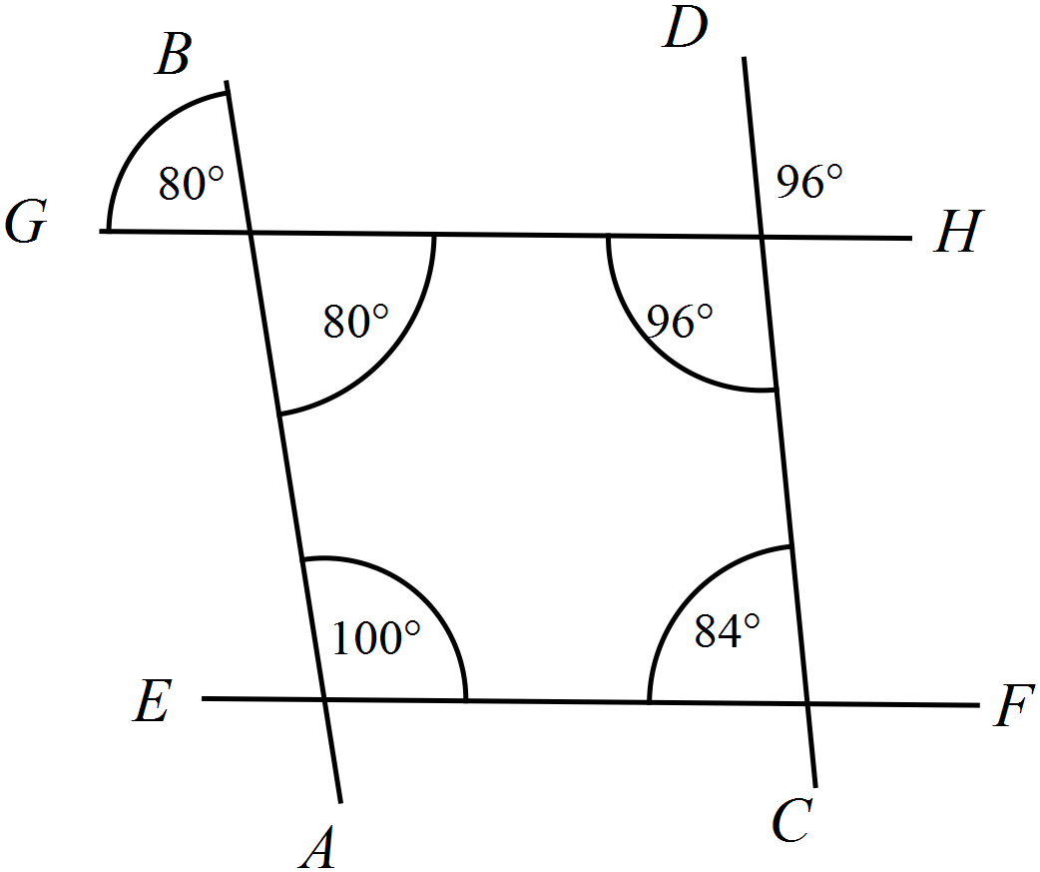  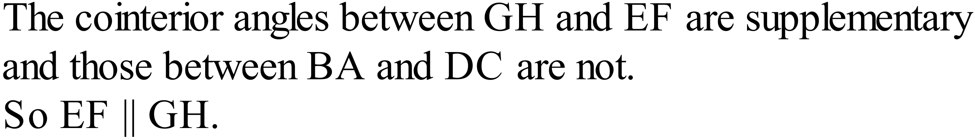 |  |  | B
 | 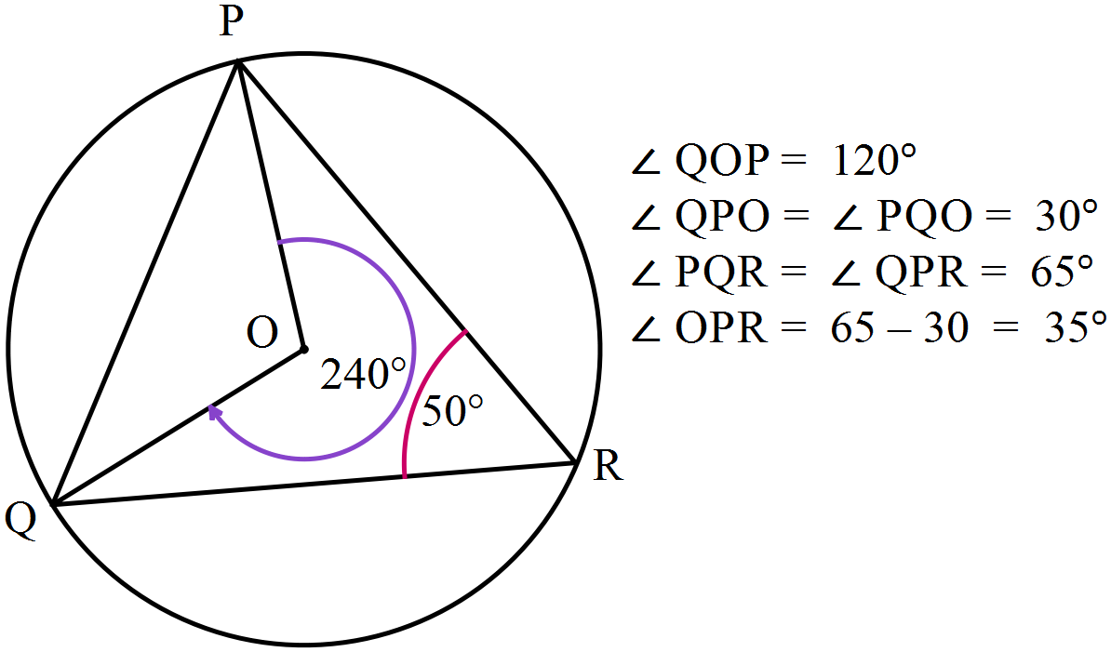 |  |  | A

Multiple Choice Answer Sheet
Basic Geometry
Name _______ANSWERS_______________________________
Completely fill the response oval representing the most correct answer.

1. A B C D
2. A B C D
3. A B C D
4. A B C D
5. A B C D
6. A B C D
7. A B C D
8. A B C D
9. A B C D
10. A B C D
11. A B C D
12. A B C D
13. A B C D
14. A B C D
15. A B C D
16. A B C D
17. A B C D
18. A B C D
19. A B C D
20. A B C D
Year 9 |  | Basic Geometry | Calculator Allowed
Section 3 Longer Answer Section
ANSWERS
 |  |  |  | Marks
1. | (a)  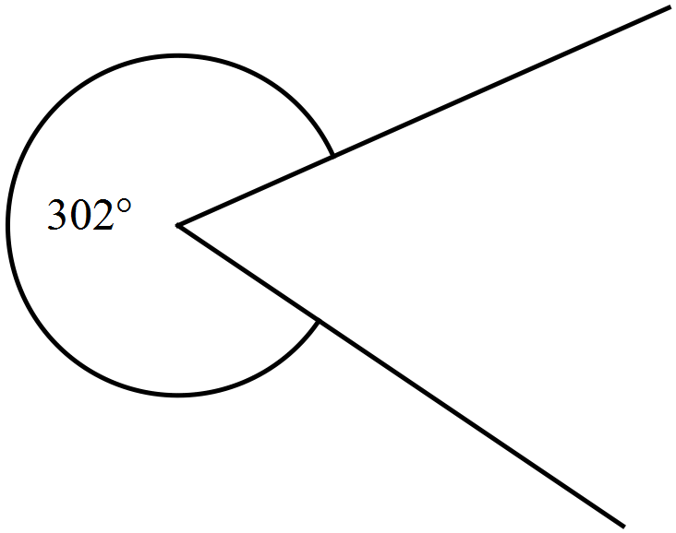 |  |  | 1
(b) A right angled triangle which also has an angle of 56º.
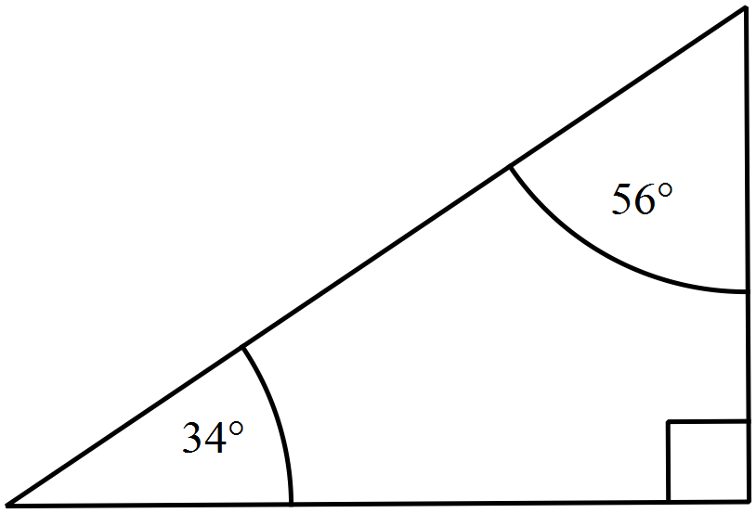

2. | (a)  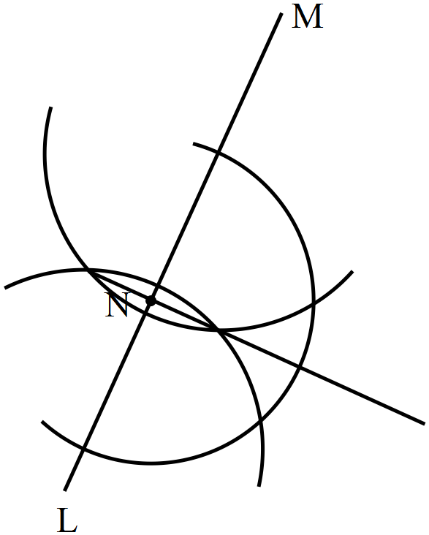 |  |  | 2
 | 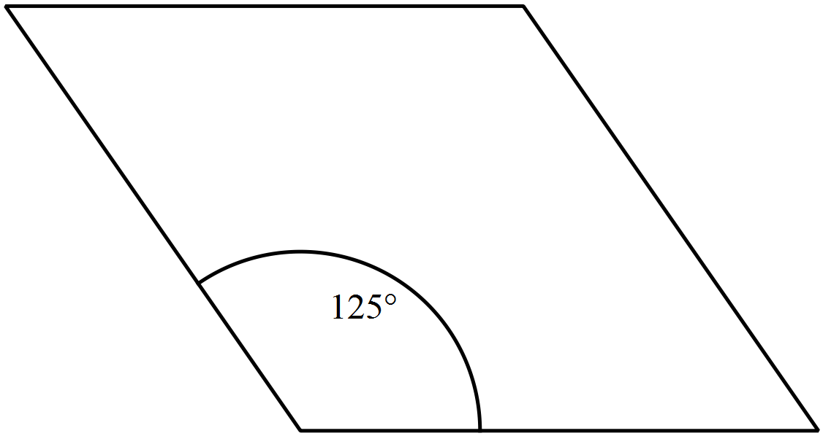(b) |  |  | 2

